PROGRAMME DE FRANÇAIS
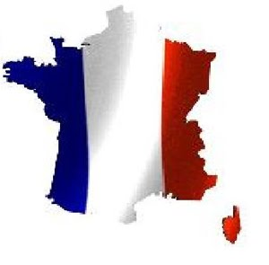
TROISIÈME COURS (E.S.O.) :
ANGLAIS/ESPAGNOL/MATHÉMATIQUES/SCIENCES NATURELLES/GÉOGRAPHIE

DEUXIÈME COURS (E.S.O.):
SCIENCES SOCIALS

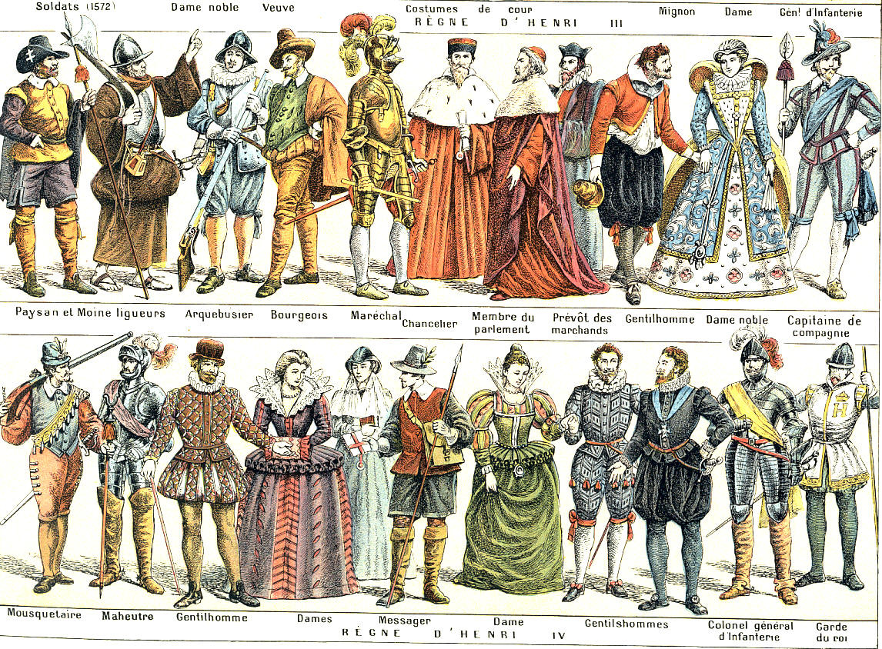

COURS BILINGUE 2010-2011
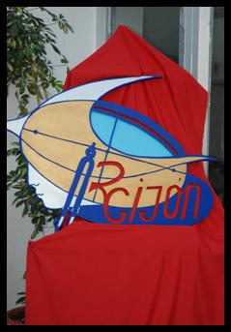 PROFESORES/AS
TODOS/AS PERTENECEN AL CENTRO:
IES RUIZ GIJÓN, DE UTRERA (SEVILLA)
Código: 41007898, Paseo De Consolación nº1, 41710 UTRERA

- 1-MARÍA JOSÉ GARCÍA ARROYO………… (Coordinadora Proyecto Bilingüe)

- 2-ENCARNACIÓN YÉBENES MONTORO….FRANCÉS :ESO/BACHILLERATO

- 3-MANUEL PÉREZ MUÑOZ…………………SCIENCES NATURELLES

- 4-JOSÉ MONTAÑO ORTEGA……………….GÉOGRAPHIE

- 5-JOSÉ ROMÁN MARTÍN………………….SCIENCES SOCIALS

- 6-CARMEN BENJUMEA…………………….MATHÉMATIQUES

- 7-ANA GLORIA RAMOS HERRERA ………LENGUA Y LITERATURA ESPAÑOLA

- 8-REMEDIOS SOLÍS RUS…………………….ANGLAIS

- 9-TATIANA BASQUE…………………..AUXILIAR LINGÜÍSTICA

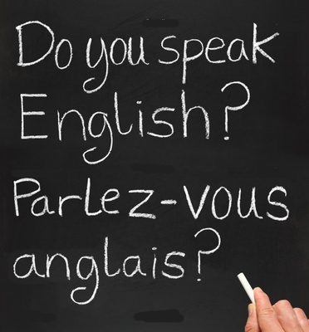



ANGLAIS
3º E.S.O.
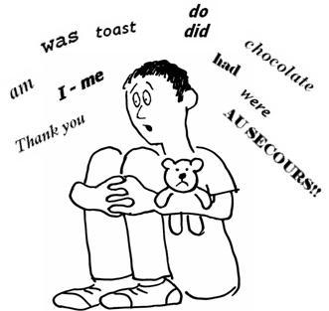

FICHA Nº 1 : EIFFEL TOWER

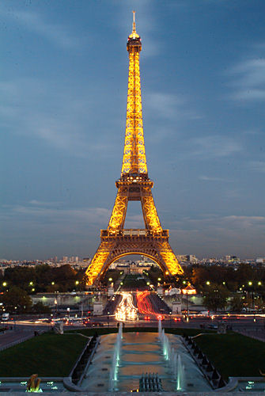

The Eiffel Tower is a 19th century iron tower located on the Champ de Mars in Paris that has become both a global icon of France and one of the most recognizable structures in the world. The Eiffel Tower, which is the tallest building in Paris, is the single most visited paid monument in the world; millions of people ascend it every year. Named after its designer, engineer Gustave Eiffel, the tower was built as the entrance arch for the 1889 World’s Fair. Eiffel originally planned to build the tower in Barcelona, for the Universal Exposition of 1888, but those responsible at the Barcelona city hall thought it was a strange and expensive construction. After the refusal of the Consistory of Barcelona, Eiffel submitted his draft to those responsible for the Universal Exhibition in Paris, where he would build his tower a year later, in 1889.
The tower stands at 324 m. tall. It was the tallest structure in the world from its completion until 1930 when it was eclipsed by Chrysler Building in New York City.
It is the second-tallest structure in France, behind the Millau Viaduct, completed in 2004.
The tower has three levels for visitors. Tickets can be purchased to ascend either on stairs or lifts to the first and second levels. The walk to the first level is over 300 steps. The third and highest level is only accessible by lift.
The tower has become the most prominent symbol of both Paris and France. Its iconic status is so established that it even serves as a symbol for the entire nation of France.

1. Answer the questions.

- Who built the Eiffel Tower?

b) Where is the Eiffel Tower situated?

c) Where did Eiffel originally plan to build the tower?

d) What is the tallest structure in France?

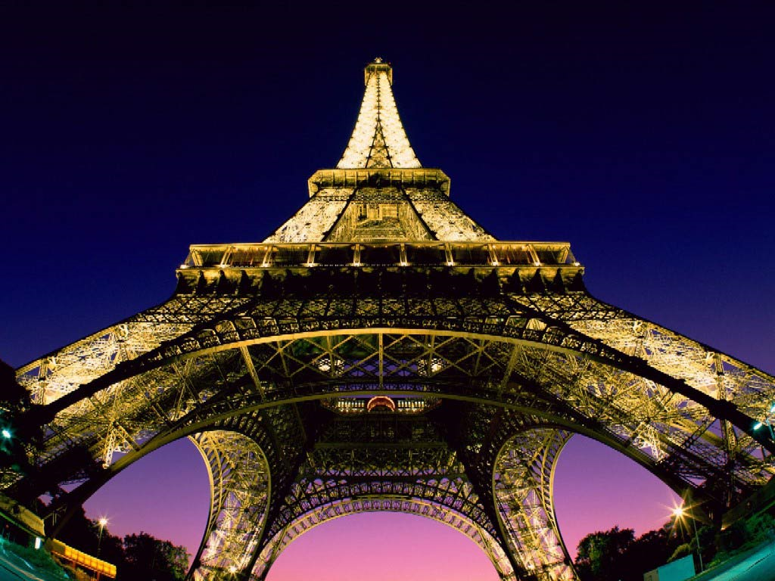

2. Write all the verbs in past tense from the text and translate them into Spanish.

-----------------------------------------------------------------------------------------------------------------------------------------------------------------------------------------------------------------------------------------------------------------------------------------------------------------------------------

FICHA Nº 2: THE LOUVRE MUSEUM

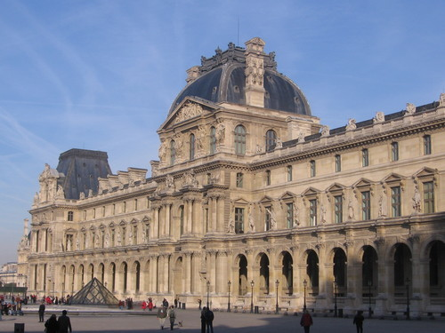

The Louvre museum is the largest national museum of France, the most visited museum in the world and a historic monument. It is located on the Right Bank of the Seine.
Nearly 35,000 objects from prehistory to the 19th century are exhibited over an area of 60,600 squares metres.
The museum is housed in the Louvre Palace which began as a fortress built in the late 12th century under Philip II. Remains of the fortress are still visible. The building was extended many times to form the present Louvre Palace.
During the French Revolution, the National Assembly decreed that the Louvre should be used as a museum, to display the masterpieces of the nation.
The museum opened on 10 August 1793 with an exhibition of 537 paintings. Because of structural problems with the building, the museum was closed in 1796 until 1801. The size of the collection increased under Napoleon and during the reigns of Louis XVIII and Charles X. During the Second French Empire the museum gained 20,000 pieces. Holdings have grown through donations and gifts since the Third Republic, except during the two World Wars.

1. Answer the questions:

Where is situated the Louvre museum?
……………………………………………………………………………………………………………………………………………………………………………………………...
Why did they decide to close the museum in 1796?
..................................................................................................................................

Which was the origin of the museum?
………………………………………………………………………………………………

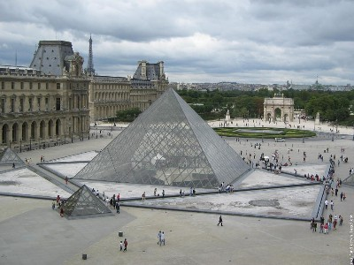

2. Write true or false and correct the false sentences.

The museum was built in the 14th century.
………………………………………………………………………………………………

The museum has objects only from prehistory.
………………………………………………………………………………………………
………………………………………………………………………………………………

The museum was closed until 1801.
………………………………………………………………………………………………

The size of the collection decreased under Napoleon.
………………………………………………………………………………………………
………………………………………………………………………………………………

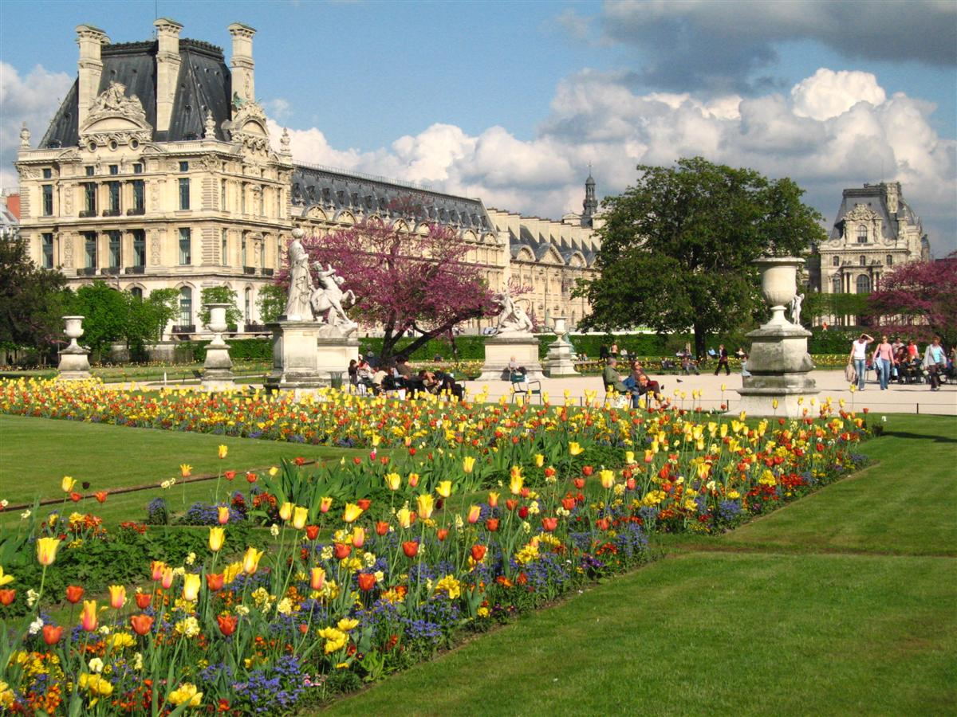

Le musée du Louvre, ancienne demeure des rois de France, est depuis deux siècles l'un des plus grands musées du monde. Ses collections sont réparties en 7 départements : Antiquités orientales, Antiquités égyptiennes, Antiquitésgrecques, étrusques et romaines ; Peintures, Sculptures, Objets d'art et Arts graphiques du Moyen Age jusqu'à 1850.

The Musée du Louvre, the former home of the kings of France, is for two centuries one now of the largest museums in the world. its collections are distributed into 7 departments: Oriental antiques, Egyptian antiques, Greek, Etruscan and Roman antiques; Paintings, Sculptures and Objets d'Art from the Middle Ages to 1850

FICHA Nº 3: FRENCH CUISINE

Bon appétit à toutes et tous !!!


French cuisine is a style of cooking derived from the nation of France. Various social movements, political movements, and the work of great chefs came together to create this movement. Through the years the styles of French cuisine have been given different names. The national cuisine developed primarily in the city of Paris with the chefs to French royalty, but eventually it spread throughout the country and it was even exported overseas.

La cuisine française fait référence à divers styles gastronomiques dérivés de la tradition française.

Beaucoup de plats régionaux, à l'origine, se sont également multipliés à travers le pays avec quelques variations d'une région à une autre.

Le fromage et le vin occupent une place d'exception dans la cuisine française, avec de nombreux produits régionaux

In French medieval cuisine, banquets were common among the aristocracy. Food was generally eaten by hand. Meals often ended with an issue de table, which later evolved into modern dessert. The ingredients of the time varied according to the seasons and the church calendar, and many items were preserved with salt, spices, honey…
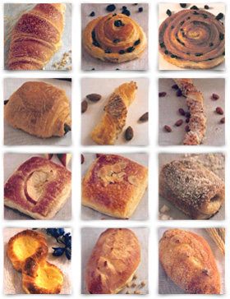
Gastro-tourism and the Guide Michelin helped to bring people to the countryside during the 20th century. Ingredients and dishes vary by region. There are many significant regional dishes that have become both national and regional. Cheese and wine are a major part of the cuisine, playing different roles regionally and nationally with their many variations.
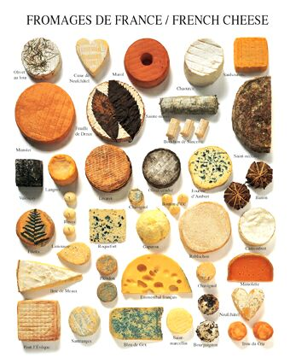

- Explain these words in English, using your own vocabulary.

Chefs:________________________________________________________

Banquets:_____________________________________________________

Dessert:_______________________________________________________

- Answer these questions:

- What is French cuisine?____________________________________

- How was food eaten in medieval cuisine?_________________________________________________

_________________________________________________________

- What ingredients are often used in French cuisine?_________________________________________________

________________________________________________________

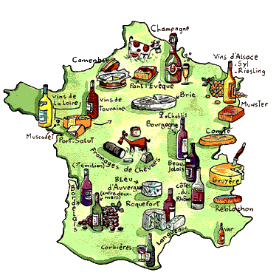

3. Look for information about a French typical dish and write all its ingredients

FICHA Nº 4: CHAMPS-ÉLYSÉES

The Avenue des Champs-Élysées is a prestigious avenue in Paris, France. With its cinemas, cafés, luxury shops, the Avenue des Champs-Élysées is one of the most famous streets in the world.
This Avenue is known in France as
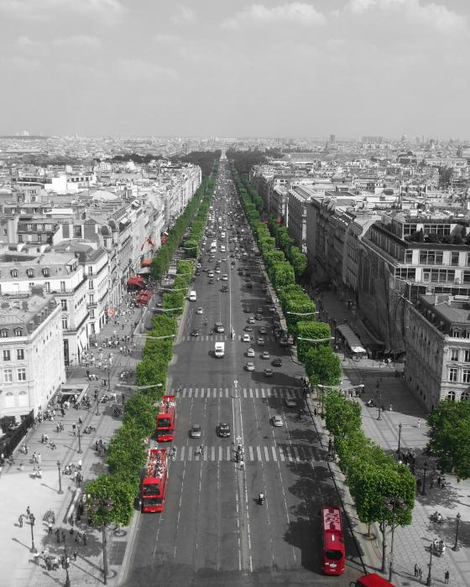
La plus belle avenue du monde (“The most beautiful avenue in the world”). It is two kilometers long, from the Place de la Concorde in the east, with the Obelisk of Luxor to the Place Charles de Gaulle in the west, location of the Arc of Triumph.
One of the principal tourist destinations in Paris, the lower part of the Champs-Élysées is bordered by greenery (Carré Marigny) and by buildings such as the Théâtre
Marigny and the Grand Palais. Further to the west, the avenue is lined with cinemas, cafés and restaurants and luxury shops. The Champs-Élysées ends at the Arc of Triumph, built by Napoleon Bonaparte in honour of his victories.
Because of the high rents, few people live on the Champs-Élysées. Rents are particularly high on the north side of the avenue. While walking among the gardens and tree-lined avenue you can even encounter an open-air marionette theatre for children, a French tradition popular through the ages.

- Answer these questions:

- How long is the Avenue?
................................................................................................................................................
- What buildings are there in this Avenue?
……………………………………………………………………
- Who built the Arc of Triumph?
................................................................................................................................................................................................
- How many people live in this Avenue? Why?
...............................................................................................................................................

- Translate these words into your language:

Luxury shops: bordered:
Greenery: Because of:
Encounter: open-air:

- Write True or False and correct the false sentences:
This avenue is two metres long…………………………………………….…..
The Avenue is lined with cinemas, cafés and restaurants and luxury shops
………………………………………………………………………..………………
The Champs-Élysées begins at the Arc of Triumph………………………….
A lot of people live on the Champs-Élysées…………………………………..

- Essay:
Have you ever visited Paris?
What places would you like to visit there? ( 50 words)
……………………………………………………………………………………………………………………………………………………………………………………………………………………………………………………………………………………………………………………………………………………………………………………………………………………………………………………………………
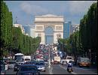

FICHA Nº 5 NAPOLEON I OF FRANCE
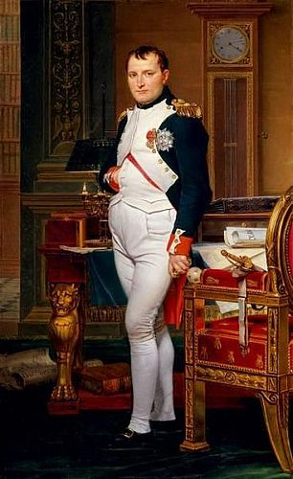
Napoleon Bonaparte was born the second of eight children, in Casa Buonaparte in the town of Ajaccio, Corsica, on 15 August 1769, one year after the island was transferred to France by the Republic of Genoa. He was initially named Napoleone di Buonaparte, acquiring his first name from an uncle who had been killed, but later he adopted the more French-sounding Napoleón Bonaparte.
He was a military and political leader of France and Emperor of the French as Napoleon I, whose actions shaped European politics in the early 19th century. In 1799, he staged a coup d´etat and installed himself as First Consul; five years later the French Senate proclaimed him Emperor. In the first decade of the nineteenth century, the French Empire under Napoleon engaged in a series of conflicts – The Napoleonic Wars. After a streak of victories, France secured a dominant position in continental Europe.
The French invasion of Russia in 1812 marked a turning point in Napoleon´s fortunes. His Grande Armée was badly damaged in the campaign and never fully recovered. In 1813, the Sixth Coalition defeated his forces at Leipzig; the following year the Coalition invaded France, forcing Napoleon to abdicate. He was exiled to the island of Elba. Less than a year later, he escaped and returned to power, but he was defeated at the Battle of Waterloo in June 1815. Napoleon spent the last six years of his life under British supervision on the island of Saint Helena. An autopsy concluded he died of stomach cancer, though Sten Forshufvud and other scientists have conjured that he was poisoned with arsenic.
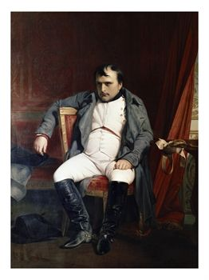

- Answer these questions:

- Who was Napoleon Bonaparte?
…………………………………………………………………………………

- How many brothers had Napoleon?
…………………………………………………………………………………
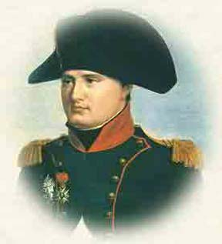
- When was Napoleon defeated?
………………………………………………………………………………..

- Where was Napoleon exiled?
…………………………………………………………………………………………

- When did Napoleon die?
…………………………………………………………………………………………

- Match these parts of sentences:

-The French invasion of Russia - under British supervision on the
Island of Saint Helena.
- In the first decade of the nineteenth century, - in 1812 marked a turning point in
Napoleon´s fortune.
- Napoleon spent the last six years of his life - the French Empire under Napoleon
engaged in a series of conflics.
- What happened in these dates?
  - On 15 August 1769:
………………………………………………………………………………………

  - In 1799:
………………………………………………………………………………

  - In 1812:
...........................................................................................................

  - In 1813:
……………………………………………………………………………………

  - In 1815:
……………………………………………………………………………….……

- Write these verbs in your language:
To abdicate:
To defeat:
To exile:
To proclaim:
To damage:
To engage:

- Find some information about his marriages and his children.
……………………………………………………………………………………………………………………………………………………………………………………………………………………………………………………………………………………………………………………………………….......................................................................................................................................................................................................................................................................................................................................................................................................................................................................................................................................................................................................................

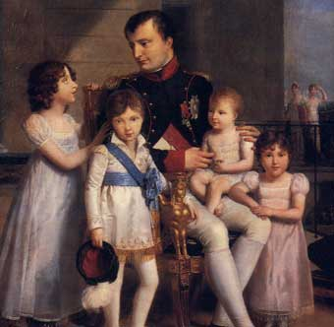

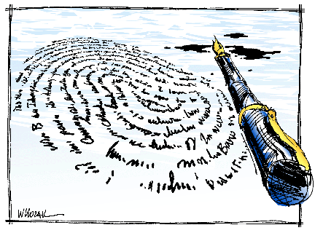
LENGUA ESPAÑOLA Y LITERATURA
3º E.S.O.
CURSO 2010/2011

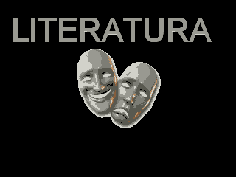

Ficha 1: Texto expositivo

Español Moderno
La lengua en el siglo XVIII con la llegada de la hegemonía y cultura francesa, todo hasta el hablar se hacía como los franceses. Llegaron un montón de galicismos en la lengua castellana como manjar, homenaje, mensaje, etc. Se tomaron algunas palabras que pasaron a ser parte de nuestro idioma como maniquí, coqueta, chaqueta, corsé, galante, sofá, etc. . A esto se añadió unas cuantas cosas como la metáfora y otras originales de los barrocos que se veían ridículos.
Se escribieron varias obras como por ejemplo el Diccionario de Autoridades (1926-1939), La Gramática en 1971, Diccionario de la Lengua Española en 1984, entre otros.
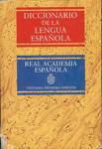
Desde 1870 empezaron a fundarse las Academias de la Lengua Española. Se instituyó una en Madrid la cual consiste en unificar los criterios lingüísticos y hacen planos de unidad de idioma para el número de personas que tienen al español como vehículo de expresión.
El galicismo ha perdido sitio ya que el anglicismo lo superó. La Real Academia ha aceptado una serie de palabras como chequear, entrenar, financiar, flirtear, etc.
ACTIVIDADES
1. Lectura atenta del texto.
2. Idea principal del texto
…………………………………………………………………………………………………………………………………………………………………………………………………………………………………………………………..
3. Búsqueda de información sobre los galicismos. …………………………………………………………………………………………………………………………………………………………………………………...………………………………………………………………………………………………..
4. Búsqueda en el diccionario de las siguientes palabras: manjar, corsé y homenaje
…………………………………………………………………………………………………………………………………………………………………………………………………………………………………………………………………………………………………………………………………………………………………………………………………………………………………………………………………………………
5. Construye un texto utilizando los términos anteriores
………………………………………………………………………………………………………………………………………………………………………………………………………………………………………………………………………………………………………………………………………………………………………………………………………………………………………………………………………………………………………………………………………………………………………………
6. Elige cinco galicismos y elabora posteriormente un texto
…………………………………………………………………………………………………………………………………………………………………………………………………………………………………………………………………………………………………………………………………………………………………………………………………………………………………………………………………………………
7. ¿El emisor se muestra preciso y objetivo o, por el contrario, transmite su percepción personal?
.............................................................................................................................................
8. ¿Qué tiempos verbales se utilizan?
..........................................................................................................................................................................................................................................................................................
Ficha 2: Texto prescriptivo

Son prescriptivos aquellos textos cuya finalidad comunicativa es actuar sobre el comportamiento del interlocutor, bien añadiendo pautas de conductas nuevas, o modificando algunas ya existentes.
Los textos prescriptivos están orientados, pues, hacia la obtención de respuestas no verbales, es decir, de acciones o conductas en el receptor. Las recetas de cocina, las instrucciones de un electrodoméstico o las leyes constituyen ejemplos de textos prescriptivos, todos ellos tienen en común el indicar las pautas de acción que el destinatario debe seguir. No apelan forzosamente a las creencias de los interlocutores. En este sentido, los textos prescriptivos se apartan de los persuasivos: los textos prescriptivos dicen cómo actuar pero no pretenden necesariamente convencer.
Por ejemplo, es perfectamente posible cumplir una ley sin estar de acuerdo con lo que ésta prescribe.
ACTIVIDADES
1. ¿Qué es un texto prescriptivo?
....................................................................................................................................................................................................................................................................................................................................................................................................................................................................................................................................................................................
2. 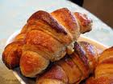Busca como ejemplo de texto prescriptivo una receta de cocina francesa
……………………………………………………………………………………………………………………………………………………………………………………………………………………………………………………………………………………………………………………………………………………………………………………………………………………………………………………………………………..…..
3. Señala las características de los textos prescriptivos a través de este texto. ………………………………………………………………………………………………………………………………………………………………………………………………………………………………………………………………………………………………………………………………………………………………………………………………………………………………………………………………………………….
4. Analiza morfológicamente las formas verbales del texto que has elegido
………………………………………………………………………………………………………………………………………………………………………………………………………………………………………………………………………………………………………………………………………………………………………………………………………………………………………………………………………………………………..…………………………………………………………………..…………
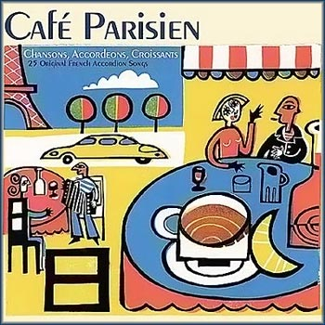
5. Realizad en grupo de cuatro distintos murales acerca de la cocina francesa.

Ficha 3: Texto narrativo
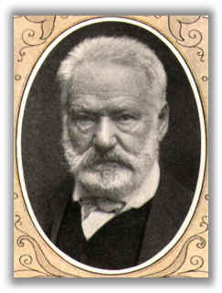
Víctor Maríe Hugo (1802 - 1885)
Nació el 26 de febrero de 1802 en Besançon.
Fue educado en escuelas privadas de París.
Desde muy joven comenzó a escribir, y ya en 1817, la Academia Francesa le premió un poema.
Fue el máximo exponente del Romanticismo francés y maestro del movimiento en el mundo.
En 1822 publicó su primer volumen de poemas, Odas y poesías diversas, al que siguieron las novelas Han ’Islande (1823) y Bug-Jargal (1824), y los poemas de Odas y baladas (1826). En el prefacio de Cromwell (1827), extenso drama histórico, Hugo plantea un llamamiento a la liberación de las restricciones que imponían las tradiciones del clasicismo.
La obra teatral, Marion de Lorme (1829), fue censurada por demasiado liberal, estaba basada en la vida de una cortesana francesa del siglo XVII. El 25 de febrero de 1830, publica su obra teatral en verso, Hernani, que tuvo un tumultuoso estreno y esto aseguró el éxito del romanticismo. Hernani fue adaptada por el compositor italiano Giuseppe Verdi y dio como resultado su ópera Ernani (1844).
Luego sigue un período de grandes producciones del autor, con su gran novela histórica Nuestra Señora de París (1831), obtuvo el nombramiento de miembro de la Academia Francesa en 1841. En 1834, publicó Claude Gueux, obra en la que condenó el sistemas penal y social de Francia de la época.
Escribió poesía lírica en varios volúmenes: Orientales (1829), Hojas de otoño (1831), Los cantos del crepúsculo (1835) y Voces interiores (1837).
Entre las obras teatrales de gran éxito se pueden nombrar : El rey se divierte (1832), adaptado por Verdi en su ópera Rigoletto (1851), el drama en prosa Lucrecia Borgia (1833) y el melodrama Ruy Blas (1838). La obra Les Burgraves (1843) no fue bien recibida por el público y fracasó.
En el gobierno de Napoleón emigró a Bélgica, donde escribió la sátira, Napoleón el pequeño (1852), los poemas satíricos Los castigos (1853), el libro de poemas líricos Las contemplaciones (1856) y el primer volumen de su poema épico La leyenda de los siglos (1859-1883).
En Guernsey terminó su más extensa y famosa obra, Los miserables (1862), una novela que describe y condena, la injusticia social de la Francia del siglo XIX.
Regresó a Francia después de 1870, y publicó El noventa y tres (1874), novela sobre la Revolución Francesa; y El arte de ser abuelo (1877), poemas líricos acerca de su vida familiar.
Falleció el 22 de mayo de 1885 en París, y sus restos fueron expuestos en el Arco de Triunfo y luego trasladados al Panteón, donde fue sepultado junto con las mayores celebridades francesas.
ACTIVIDADES
1. Lee el texto atentamente.
2. Define el concepto de biografía.
…………………………………………………………………………………………………………………………………………………………………………………………………………………………………………………………………………………………………………………………………………………………………………………………………………………………………………………………………………………
3. Señala las características de esta tipología textual en el texto
…………………………………………………………………………………………………………………………………………………………………………………………………………………………………………………………………………………………………………………………………………………………………………………………………………………………………………………………………………………
4. Busca información sobre otro autor francés y elabora su biografía.
AUTOR
………………………………………………………………………………………………………………………………………………………………………………………………………………………………………………………………………………………………………………………………………………………………………………………………………………………………………………………………………………………………………………………………………………………………………………………………………………………………………………………………………………………………………………………………………………………………………..
FOTO
TEXTO
………………………………………………………………………………………………………………………………………………………………………………………………………………………………………………………………………………………………………………………………………………………………………………………………………………………………………………………………………………………………………………………………………………………………………………………………………………………………………………………………………………………………………………………………………………………………………………………………………………………………………………………………………………………………………………………………………………………………………………………………………………………………………………………………………………………………………………………………………………………………………………………………………………………………………………………………………………………………………………………………………………………………………………………………………………………………………………………

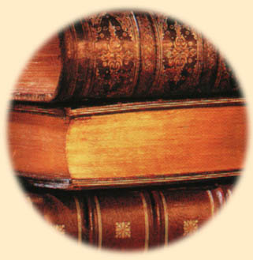Ficha 4: El lenguaje literario
1. ¿Qué es literatura?
..............................................................................................................................................................................................................................................................................................................................................................................................................................................................
2. ¿Cuales son las principales figuras retóricas?
…………………………………………………………………………………………………………………………………………………………………………………………………………………………………………………………………………………………………………………………………………………………………………………………………………………………………………………………………………………………………………….
3. Define los conceptos de poema, verso y rima
……………………………………………………………………………………………………………………………………………………………………………………………………………………………………………………………………………………………………………………………………………………………………………………………………………………………………………………………………………………………………………………………………………………………………………………………………………………………………………………………………………

Poema Plenitud , de Víctor Hugo

Puesto que apliqué mis labios a tu copa llena aún,
y puse entre tus manos mi pálida frente;
puesto que alguna vez pude respirar el dulce aliento
de tu alma, perfume escondido en la sombra.

Puesto que me fue concedido escuchar de ti
las palabras en que se derrama el corazón misterioso;
ya que he visto llorar, ya que he visto sonreír,
tu boca sobre mi boca, tus ojos en mis ojos.
Ya que he visto brillar sobre mi cabeza ilusionada
un rayo de tu estrella, ¡ay!, siempre velada.
Ya que he visto caer en las ondas de mi vida
un pétalo de rosa arrancado a tus días,
puedo decir ahora a los veloces años:
¡Pasad! ¡Seguid pasando! ¡Yo no envejeceré más!
Idos todos con todas nuestras flores marchitas,
tengo en mi álbum una flor que nadie puede cortar.
vuestras alas, al rozarlo, no podrán derramar
el vaso en que ahora bebo y que tengo bien lleno.
Mi alma tiene más fuego que vosotros ceniza.
Mi corazón tiene más amor que vosotros olvido.

4. Lee atentamente el poema.
5. Cada alumno leerá un verso en voz alta.
6. Mide los cuatro primeros versos.
7. Marca la rima del texto.
8. Busca ejemplos de metáfora, anáfora, paralelismo e hipérbaton.
9. ¿Cuál es el tema del poema?
…………………………………………………………………………………………………………………………………………………………………………………………………………………………………………………………………………………...................................................................................................................................................................................................................................................................................................
10. Intenta crear dos estrofas de cuatro versos.
……………………………………………………………………………………………………………………………………………………………………………………………………………………………………………………………………………………………………………………………………………………………………………………
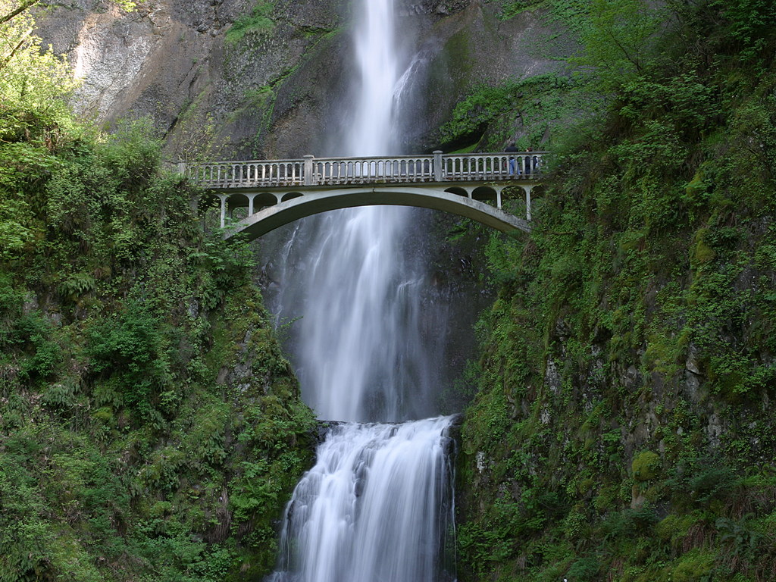
……………………………………………………………………………………………………………………………………………………………………………………………………………………………………………………………………………………………………………………………………………………………………………………

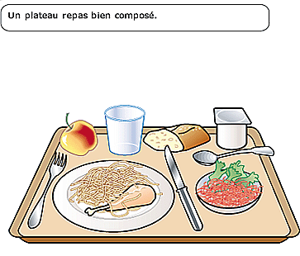

SCIENCES NATURELLES

3º E.S.O.

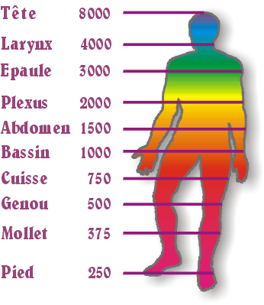

THÈME 1

L’ORGANISATION DU CORPS HUMAIN

LA DURÉE: mois de septembre

CONTENUS:
- La cellule.
- L’organisme.
- Tissus et organes.
- Appareils et systèmes.
- Relation entre appareils.

VOCABULAIRE

- cellule
- tissus
- organes
- appareil digestif
- appareil respiratoire
- appareil circulatoire
- appareil excrétoire
- appareil locomoteur
- appareil reproducteur
- système nerveux
- système endocrinaire
- organisme
-nutriments
- nutrition
- reproduction
- organes sensoreils : la vue, l’ouïe, l’odorat, le goût, le touché

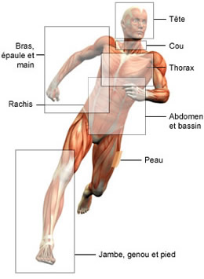

ACTIVITÉS :
- Relie les termes de chaque colonne
Vue

Endocrine
Circulatoire

protection
Appareil

peau
Système

Organes sensoriels

- Quels appareils interviennent dans la fonction nutritive ?
........................................................................................................................................................................................................................................

- Quels organes et systèmes interviennent dans la fonction de relation ?
……………………………………………………………………………………………………………………………………………………………………………………….

- Chercher le vocabulaire suivant :

- Hígado……………………………………………………………………………………………………………
- Páncreas………………………………………………………………………………………………………….
- Corazón…………………………………………………………………………………………………………….
- Pulmón……………………………………………………………………………………………………………
- Ovarios…………………………………………………………………………………………………………….
- Riñón……………………………………………………………………………………………………………….
- Estómago………………………………………………………………………………………………………
- Intestinos……………………………………………………………………………………………………….

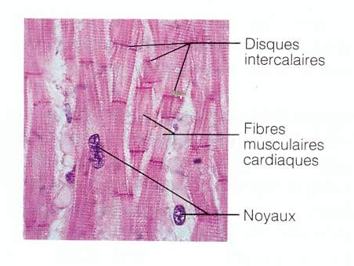

THÈME 2

L’ETRE HUMAIN ET LA SANTÉ

LA DURÉE : 1er quinzaine d’octobre

CONTENUS :
- Type de maladies
- Maladies infectieuses
- Maladies non infectieuses
- Assistance sanitaire
- Transplants

VOCABULAIRE

-Santé
-Maladie
-infectieuse
-bactéries
-infection
-incubation
-convalescence
-vaccination
-habitude de vie saine
-transplant
-cancer
-défenses
-prévention

-virus
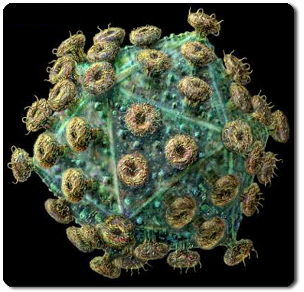

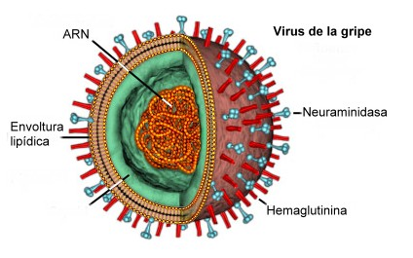

Activités :

- Cherche les mots du thème dans la grille de mots-mêlés.
(4 mots)

D | R | B | E | E | F | V | G | I | O
A | F | A | R | T | B | A | J | F | R
Q | F | C | G | H | K | C | A | G | P
D | U | B | D | J | K | C | L | E | I
R | M | A | L | A | D | I | E | S | F
U | K | C | Q | G | T | N | U | Q | G
C | Z | T | M | F | F | N | H | R | O
X | C | E | Z | Y | X | B | E | S | H
X | X | R | Q | W | K | Y | G | E | U
H | V | I | R | U | S | M | N | K | H
I | I | E | O | R | T | I | L | F | W

- Cherchez des informations sur les différents types de transplants qui existent aujourd’hui.
..............................................................................................................................................................................................................................................................................................................

- Les virus sont-ils des êtres vivants ? Construit ta réponse.
...............................................................................................................................................................................................................................................................................................................

- Réalise une liste de moyens préventifs d’accidents de la route en relation avec :
  - le conducteur
………………………………………………………………………………………………
  - les passagers
………………………………………………………………………………………………
  - la moto
………………………………………………………………………………………………
  - la route
…………………………………………………………………………………………….

- Quelles sont les défenses naturelles ?
................................................................................................................................................................................................................................................................................................................

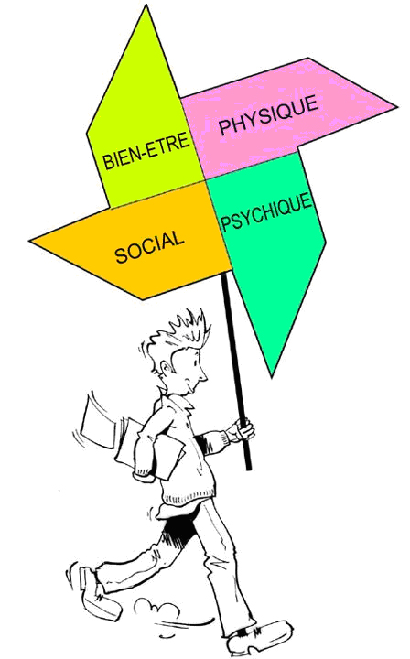

THÈME 3

ALIMENTATION ET NUTRITION

LA DURÉE : 2ème quinzaine d’octobre

CONTENUS :
- principes immédiats
- besoins nutritionnels
- diètes
- habitudes alimentaires

VOCABULAIRE

glucides
lipides
protéines
vitamines
sels minéraux
eau
nutriments
métabolisme
Diète alimantaire
Diète équilibrée
Diète méditerranéenne
Cholestérol
Desnutrition
Maladie de carence
Habitudes alimentaires
Aliments transgéniques

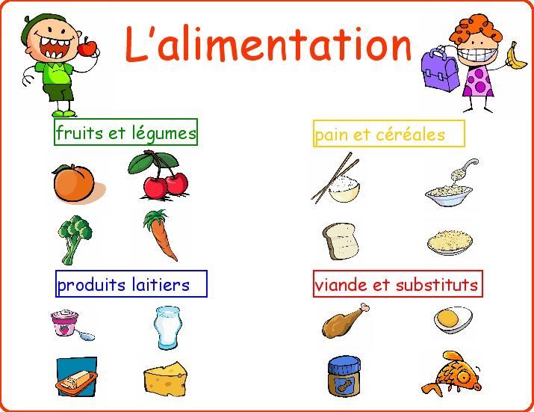

Activités :

- Chercher 5 mots en relation avec les termes :
  - Glucide
  - Lipide
  - Protéine
  - Vitamine
  - Diète
  - Nutriment

- Explique ce que signifie diète équilibrée :
............................................................................................................................................................................................................................................

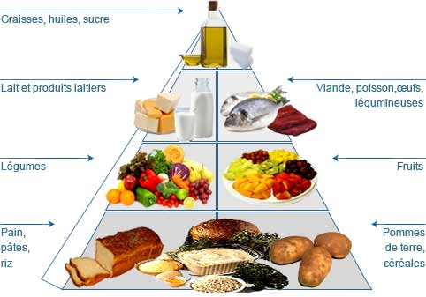

S'agit d'un régime alimentaire varié, qui apporte un peu de tout, et autant de calories que nécessaire, ni trop, ni pas assez.
L'équilibre provient des trois grandes sources caloriques que sont les glucides (ou sucres), les lipides (ou graisses) et les protéines.

3-Qu’est-ce que l’obésité ? dans quels pays est-il présent ? Comment peut-il être exterminé ?
................................................................................................................................................................................................................................................................................

4-Cherche des informations sur les maladies produites par une diète alimentaire insuffisante ?
................................................................................................................................................................................................................................................................................

5-Cherche les mots de vocabulaire dans la grille de mots mêlés (6 mots)

T | N | V | M | T | T | E | G | S | U
E | R | P | E | R | C | A | Y | L | Q
O | P | R | D | M | N | G | L | D | T
Q | W | O | G | L | U | C | I | D | E
F | H | T | S | N | T | D | P | L | E
D | C | E | M | Q | R | H | I | J | P
R | T | I | V | R | I | F | D | R | B
D | V | N | I | V | M | Q | E | U | R
D | I | E | T | E | E | F | U | U | I
E | R | D | A | A | N | X | F | N | M
D | F | V | M | E | T | S | U | D | U
D | E | U | I | B | M | D | H | J | L
C | F | L | N | D | A | T | R | H | M
W | G | N | E | G | S | R | E | Y | S
F | B | Q | A | F | U | O | P | Q | F

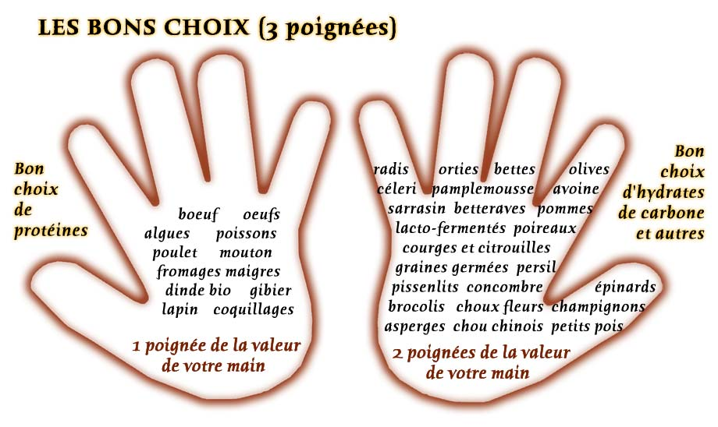

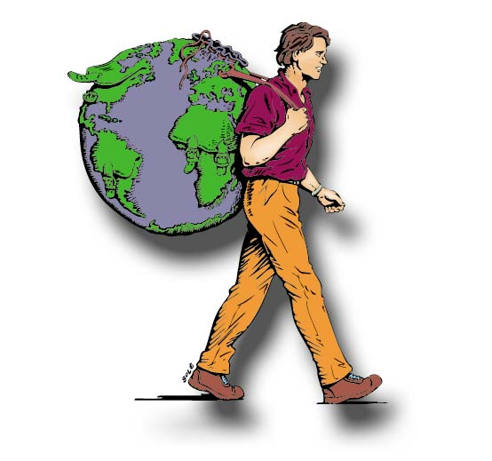

GÉOGRAPHIE

TROISIÈME E.S.O.
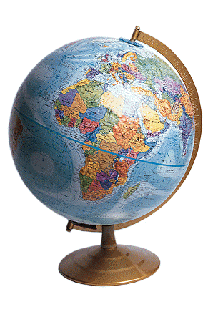

UNITÉ 1 :
LES CONTINENTS
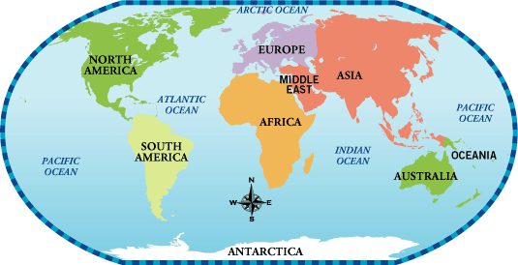
Un continent est une inmense étendue de terre entourée par des océans. Il y a six continents:

- L´Afrique. C´est un continent très massif et uniforme. Son relief est constitué principalement par des plateaux et par des Bassins.

- L´Amérique. Ce continent se divise en trois grandes unités: l´Amérique du Nord, l´Amérique centrale et l´Amérique du Sud.

L´Amérique présente, a L´ouest, de jeunes montagnes; au centre, des grandes plaines traversées par des fleuves, et à l´est, des massifs très anciens.

- L´Asie. Elle est située à l´est de l´Eurasie. Dans l´Asie nous pouvons différencier quatre grandes parties: des plaines et des plateaux, au nord; des cordillères très élevées, au centre-sud; de grandes presqu´îles, dans l´Océan Indien; des archipiels, dans l´Océan Pacifique.

- L´Europe. Elle est située a l´ouest de l´Eurasie. L´Europe est séparée de l´Asie par l´Oural et par le Caucasse. La mer Méditerranée sépare l´Europe de l´Afrique.

- L´Océanie. Ce continent est formé par dix mille îles. L´île principale c´est l´Australie.

- L´Antarctique. Elle est située au Pôle Sud, entre l´Océan Pacifique, Atlantique et Indien.

ACTIVITÉS

Répondez aux questions en utilisant le planisphère du livre de l´élève, page 9.

- Quels sont les continents de la Terre? ……………………………………………………………………………………………………...….

- Quelles sont et oú se situent les grandes cordillères d´Amérique? Citez les grands fleuves de ce continent
……………………………………………………………………………………………………………………………………………………………………………………………………………………

- 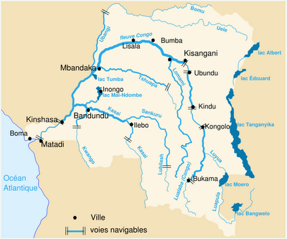 Quels sont les principaux fleuves d´Afrique. Expliquez le relief de ce continent
……………………………………………………………………………………………………………………………………………………………………………………………..

- Citez trois fleuves d´Asie. Situez la plus grande montagne de ce continent
……………………………………………………………………………………………………………………………………………………………………………………………………………………………………………………………………………………….………

- 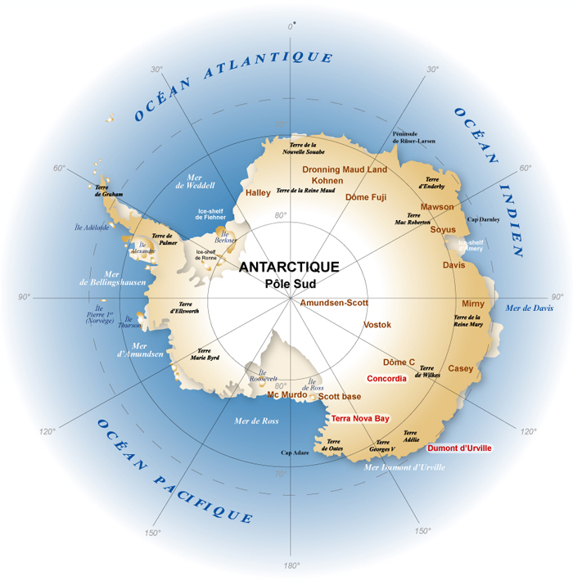 Oú est située l´Antarctique
………………………………………………………………………………………………………………………………………………………………………………………………………………………………………………………………………………………………

- Quelle est l´île principale de l´Océanie
…………………………………………………………………………………………..………………………………………………………………………………………………………………………………………………………………………………………………………………………………………………..…..

UNITÉ 2 :
LE RELIEF, LES FLEUVES ET LES CÔTES D´EUROPE
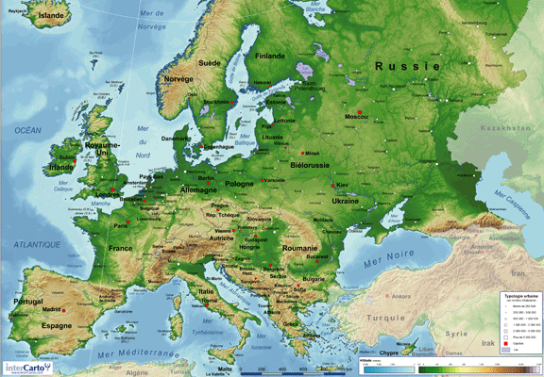
- Le relief d´Europe
L´Europe présente deux grands types de relief: les montagnes et les plaines, traversées par des fleuves.

- Les montagnes
Il faut distinguer deux types de montagne: les massifs et les montagnes jeunes.

  - Les massifs, formés il y a très longtemps, sont usés par l´érosion: leurs sommets sont arrondis et leurs altitudes sont moyenne.
Ils sont situés au nord, à L´ouest, et au centre du continent: la Chaîne Scandinave, le Massif Central Français...
Ces reliefs sont séparés par des vallées traversées par des fleuves: le Rhin, La Seine, et la Loire.

  - Les montagnes jeunes, formées plus récemment, sont plus élevées et des sommets plus découpés. Elles occupent la plus grande parte de l´Europe. Les plus importants sont: les Pyrénnées, les Alpes, les Carpates, les Balkans.
Par ces reliefs circulent beaucoup de fleuves, comme le Rhône ou le Danube.

- Les plaines

La Grande Plaine Européenne est la forme de relief la plus étendue d´Europe. Elle occupe plus de la moitié de sa surface, de la Belgique jusqu´à la Sibérie.
Les grands fleuves européens circulent á travers les vallées de la Grande Plaine Européenne. Le plus important c´est le Volga.

- Les côtes d´Europe
Le continent européen présente, en général, des côtes de formes découpées. En fonction du relief et des océans ou des mers qui baignent les côtes on peut distinguer: la côte atlantique et la côte méditerranée.
Également il y a des côtes basses et des côtes à falaises. Dans les côtes basses les cours d´eau forment des deltas.
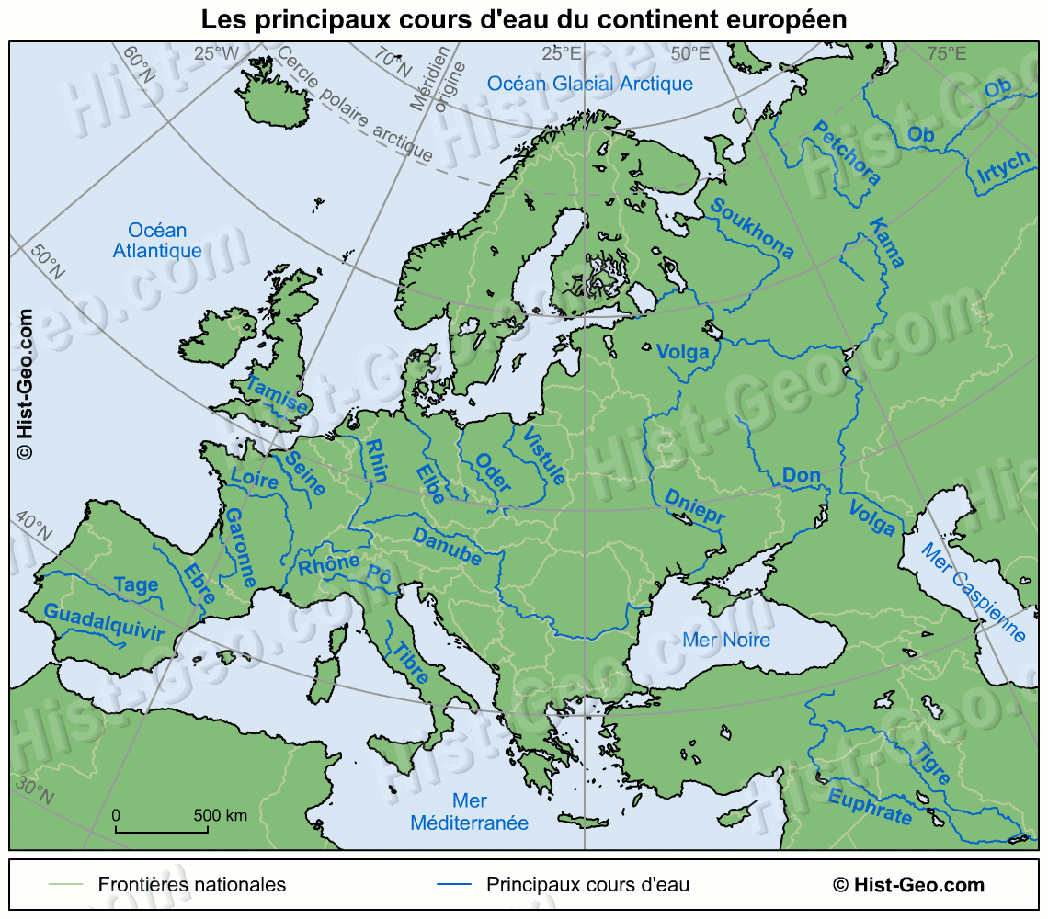
ACTIVITÉS

Répondez aux questions en utilisant la carte d´Europe du livre de l´élève, page 11.

- Citez les trois grandes unités du relief européen. Oú sont situés les sommets les plus élevés? Quels sont-ils?
……………………………………………………………………………………………………………………………………………………………………………………………………………………………
- Citez les fleuves les plus importants d´Europe.
………………………………………………………………………………………………………………………………………………………………………

- Quelles sont les principales presqu´iles, archipels, et îles du continent?
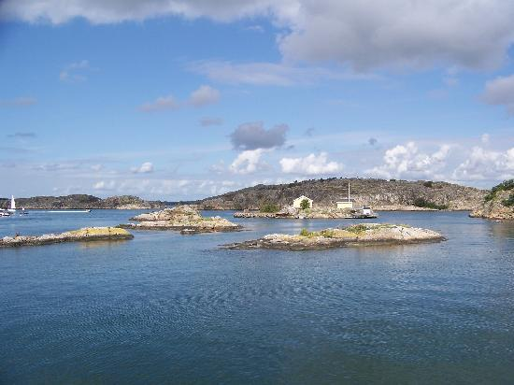
……………………………………………………………………………………………………………………………………………………………………………………………………………………………..

- Quels sont les deux types de côtes européennes?
…………………………………………………………………………………………………………………………………………………………………………………………..………………………………….

- Comment distinguer-t-on le massif de la montagne jeune?
……………………………………………………………………………………………………………………………………………………………………………………………………………………………….………………………………………………………………

UNITÉ 3 :
LES PAYSAGES D´EUROPE

1. Les paysages d´Europe
Les trois grands types de paysages d´Europe sont: le paysage océanique, le paysage méditerranéen, le paysage continental.

2. Le paysage océanique
Le paysage océanique est situé à l´ouest du continent. Les vents venus de la mer rafraîchissent les étés, adoucissent les hivers et apportent des pluies abondantes toute l´année.

La végétation naturelle est la forêt d´arbres à feuilles caduques et la lande sur les côtes exposées aux vents. Mais la forêt a été remplacée par des cultures ou des prairies pour l´élevage, où l´habitat est dispersé.
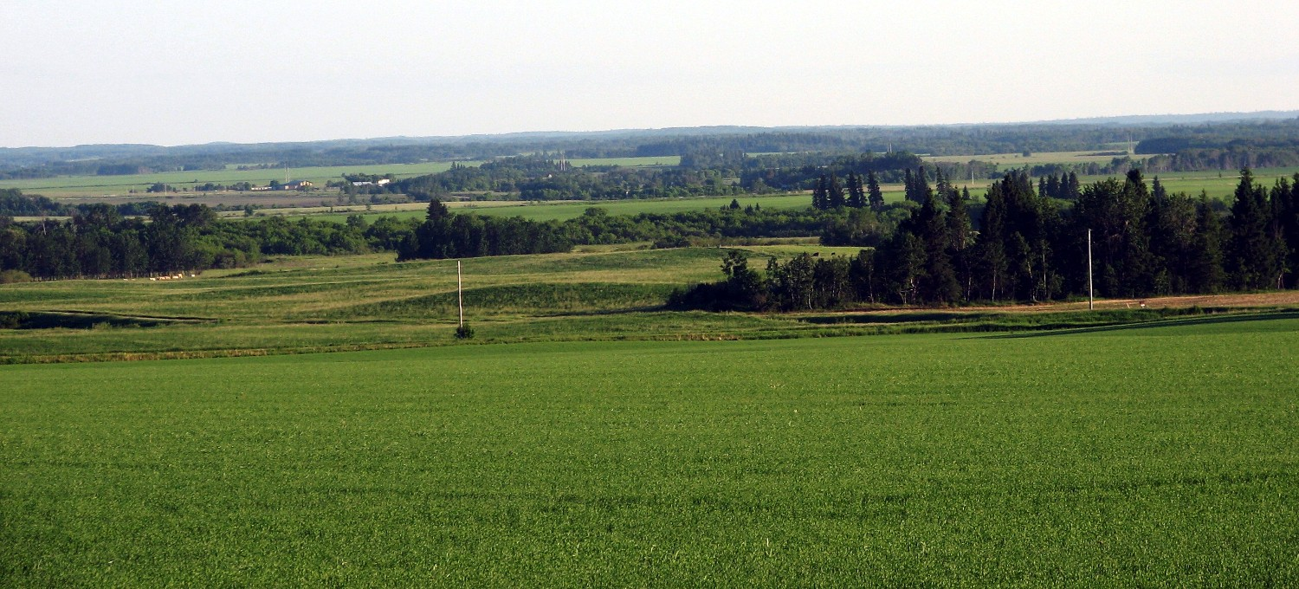
3. Le paysage méditerranéen
Le paysage méditerranéen est propre des côtes et des îles baignées par cette mer. IL a des étés chauds et ensoleillés et des hivers doux.
La végétation naturelle est la forêt qui a souvent évoluée en garrigue ou en maquis. Le climat méditerranéen attire les touristes et les personnes âgées.
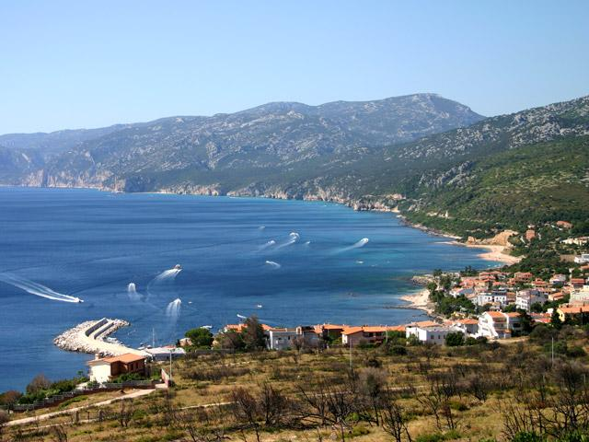

4. Le paysage continental
À l´intérieur du continent, l´influence de l´océan et de ses vents humides diminue: c´est le paysage continental. Les hivers sont froids et les étés chauds. Les précipitations sont peu abondantes.

La forêt couvre encore d´inmmenses espaces de la Russie (où on l´appelle taïga). Plus au sud, la formation végétale naturelle qui domine est la prairie, mais elle a été remplacée par des cultures de céréales.

La population vit groupée dans de grandes villages, mais aujourd´hui les villes, les voies de communication, l´activité industrielle, ont modifié les paysages traditionnels.
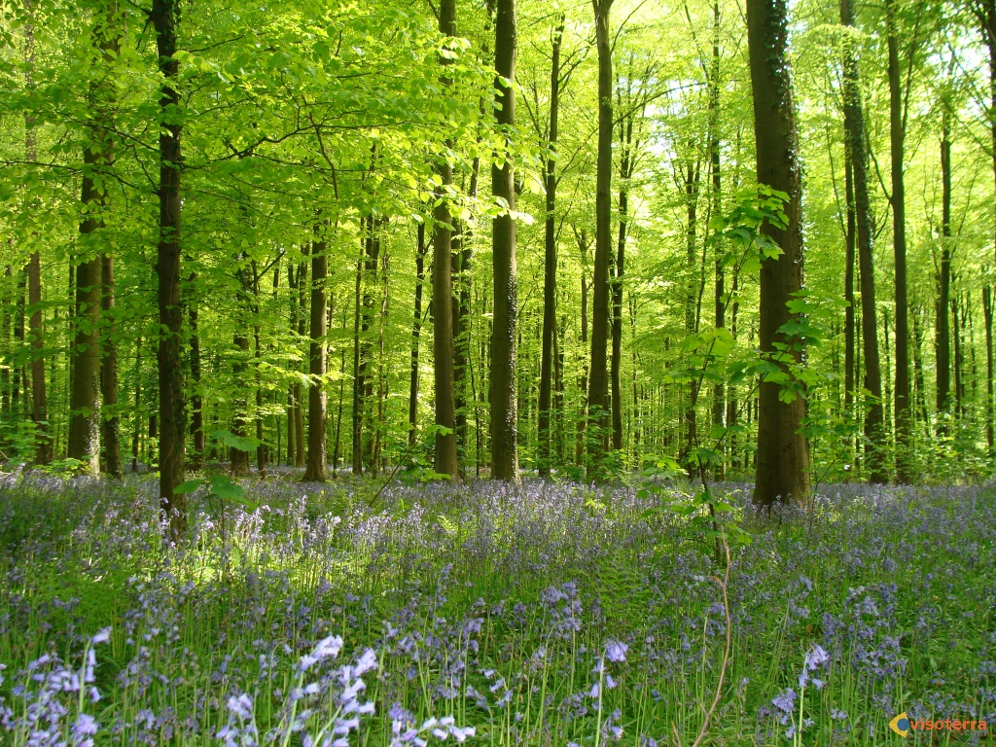

ACTIVITÉS

Répondez aux questions en utilisant la carte d´Europe du livre de l´élève, page 27.

- Quels sont les trois principaux types de paysages d´Europe?
…………………………………………………………………………………………………………………………………….……………………………………………………….

- Quelle est la végétation typique du paysage méditerranéen?
........................................................................................................................................................................................................................................................................................................................................................................................................................

- Expliquez l´habitat du paysage continental?
………………………………………………………………………………………………………………………………………………………………………………………………………………………………………………………………………..……………………

- Quelles sont les zones touchées par le climat océanique?
…………………………………………………………………………………………………………………………………………………………………………………………..…

- Complète le tableau:

Paysages tempérés | Localisation | Températures | précipitations
Océanique |  |  | abondantes
Méditerranéen
continental

VOCABULAIRE

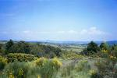
La garrigue: formation végétale méditerranénne formée de petits buissons bas et clairsemés.

La Lande:
Végétation du milieu océanique constituée des bruyères, d´anjoncs et de genêts.
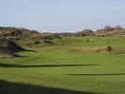

Le maquis: formation végétale méditerranéenne constituée d´arbustes et de buissons touffus
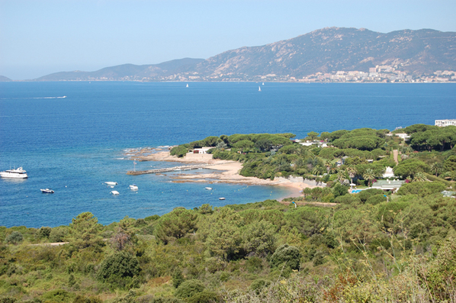.

La taïga: forêt de Sibérie formée de bouleaux et de sapins.
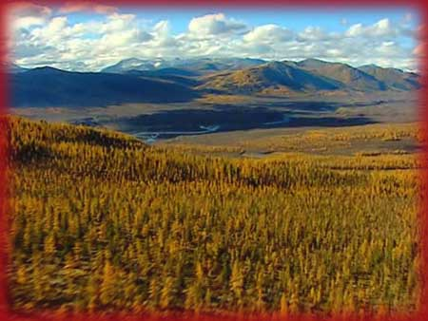

MATHÉMATIQUES

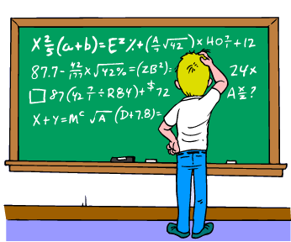

TROISIÈME COURS

ENSEIGNEMENT SECONDAIRE OBLIGATOIRE

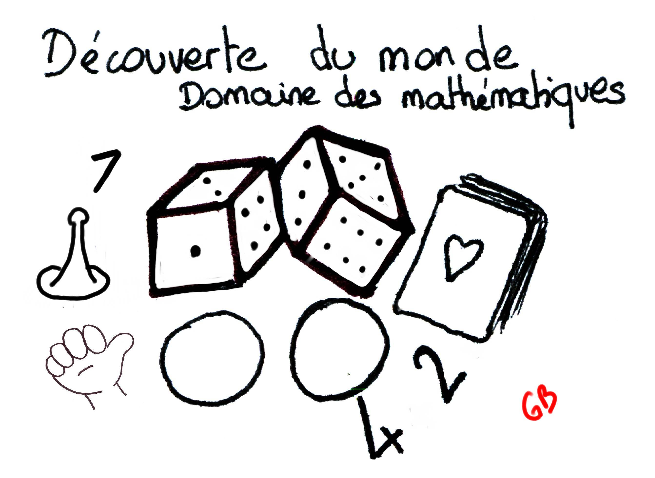

PROGRAMME DU

TROISIÈME COURS DE MATHÉMATIQUES

THÈME 1: NOMBRES RATIONNELS.
THÈME 2: PUISSANCES ET RACINES
THÈME 3: ÉQUATIONS ET SYSTÈMES D’ÉQUATIONS
THÈME 4: FONCTIONS
THÈME 5: INTRODUCTION À LA TRIGONOMÉTRIE
THÈME 6: MOUVEMENTS DANS LE PLAN
THÈME 7: LA SPHÈRE TERRESTRE
THÈME 8: STATISTIQUE ET PROBABILITÉ

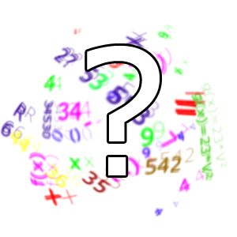

THÈME 1
LES NOMBRES RATIONNELS

OBJECTIFS:

Après un bref rappel des nombres entiers et relatifs

- Les élèves doivent connaître les trois signifiés des fractions et apprendre à les lire.
- Il faut qu’ils sachent les représenter sur la droite graduée.
- Les élèves apprendront à faire les opérations basiques entre fractions.
- Il faut que les élèves comprennent l’équivalence entre fraction et nombre décimal.
- Les élèves apprendront à obtenir la valeur décimale d’une fraction et la valeur en fraction d’un nombre décimal.
- Les élèves doivent apprendre la lecture des décimaux.
- À la fin du thème, les élèves connaîtront l’ensemble des nombres rationnels.

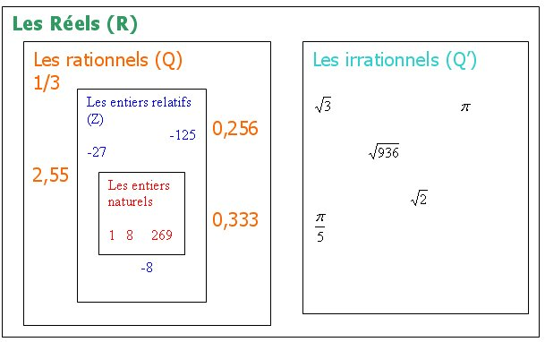

RAPPELLE-TOI :

1) L’ensemble des entiers naturels .
C’est l’ensemble de tous les entiers positifs ou nul. On le note (de l’italien naturale)

2) L’ensemble des entiers relatifs

C’est l’ensemble de tous les entiers positifs, négatifs et nul. On le note (de l’allemand zahlen : compter)

3) Diviseurs et multiples.

Le nombre a est divisible par b s’il existe un nombre n tel que: a = b x n. On dit alors que a est multiple de b et de n.
Exemple :
10 = 2x5 donc 10 est divisible par 2 et par 5, et 10 est un multiple de 2 et 5 (il y en a d’autres).

a) Critères de divisibilité. (rappels de sixième)

- Par 2: Un nombre est divisible par 2 s’il est pair, c’est-à-dire lorsqu’il se termine par 0, 2, 4, 6 ou 8.
- Par 3: Un nombre est divisible par 3 si la somme des chiffres qui le composent est divisible par 3.
- Par 5: Un nombre est divisible par 5 s’il se termine par 0 ou par 5.
- Par 9: Un nombre est divisible par 9 si la somme des chiffres qui le composent est divisible par 9.
Exemple :
• 675 est divisible par 9 car 6+7+5=18 et 18 est divisible par 9.
•114 est divisible par 3 car 1+1+4 = 6 et 6 est divisible par 3.

b) Diviseurs communs.

Un diviseur commun de deux nombres a et b est un nombre qui divise à la fois a et b.
Exemple :
3 est un diviseur commun de 114 et 27 car 3 divise 114 (114 = 3x38) et 3 divise 27 (27=3x9).

c) Plus Grand Commun Diviseur (PGCD).

Le PGCD de deux nombres a et b est le plus grand des diviseurs communs de a et de b.
Deux nombres sont premiers entre eux lorsque leur PGCD est 1, c’est-à-dire lorsqu’ils n’ont comme diviseur commun que le nombre 1.
Exemple:
8 et 27 sont premiers entre eux car ils n’ont comme diviseur commun que 1, leur PGCD est 1.
Algorithmes de calcul du PGCD de deux nombres a et b:
Un algorithme est une succession de règles ou de procédures bien définies qu’il faut suivre pour obtenir la solution d’un problème dans un nombre fini d’étapes.

- L’algorithme d’Euclide pour lequel nous révisons en premier lieu la division euclidienne:
- Division euclidienne (rappels de sixième) : Soit a et b deux entiers avec a > b alors il existe un unique couple d’entiers (q,r) tel que a = bq+r (avec r< b )
  - a est appelé "le dividende"
  - b est appelé "le diviseur" a b
  - q est appelé "le quotient" r q
  - r est appelé "le reste"
Exemple :
Donnons l’égalité de la division euclidienne de 65 par 32 65 = 32x2+1.

L’algorithme d’Euclide repose sur la propriété suivante:
- Propriété : Soit a et b deux entiers avec a > b et r le reste de la division euclidienne de a par b, alors pgcd (a ; b) = pgcd (b ; r)

Exemple :

Calcul du PGCD de 675 et 375 par l’algorithme d’Euclide
675 = 375 × 1 + 300 donc pgcd(675;375) = pgcd(375;300)
375 = 300 × 1 + 75 donc pgcd(375;300) = pgcd(300;75)
300 = 4x75 + 0 donc pgcd(300;75) = pgcd(75;0) = 75
Le dernier reste non nul est 75 Donc le pgcd (675,375)=75.
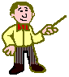
- L’algorithme des décompositions en produits de facteurs premiers: Soit a et b deux entiers chacun d’eux décomposés en produits de facteurs premiers. Prenons tous les facteurs communs des deux décompositions ; s'ils ont des exposants, nous leur attribuons leur plus petit exposant ; effectuons ensuite le produit pour obtenir finalement le pgcd(a,b).
Exemple:
Calcul du PGCD de 675 et 375 par décomposition
675 = 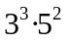 375 = 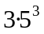 alors pgcd(675 ;375) =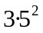= 3·25 = 75.

d) Plus Petit Commun Multiplicateur (PPCM)

Le PPCM de deux nombres a et b est le plus petit des multiplicateurs communs de a et de b.
Pour calculer le PPCM de deux nombres entiers, chacun d’eux décomposés en produits de facteurs premiers, prenons tous les facteurs qui figurent dans l'un au moins de ces produits ; s'ils ont des exposants, nous leur attribuons leur plus grand exposant ; effectuons ensuite le produit pour obtenir finalement le ppcm(a,b).
Exemple:
Calcul du PPCM de 72 et 132 par décomposition
72 = 2 x 2 x 2 x 3 x 3 = 2³ x 3² 132 = 2 x 2 x 3 x 11 = 2² x 3¹ x 11¹
alors ppcm(72, 132) = 2³ x 3² x 11¹ = 8 x 9 x 11 = 792

4) L’ensemble des nombres rationnels:
La division de deux nombres entiers ne donne pas forcément un nombre entier
Avec la division, on sort du territoire des entiers relatifs
Le résultat de la division de deux nombres entiers est toujours un nombre avec des décimales périodiques, au moins à partir d'un certain rang
Ce sont les nombres rationnels, ou fractionnaires.
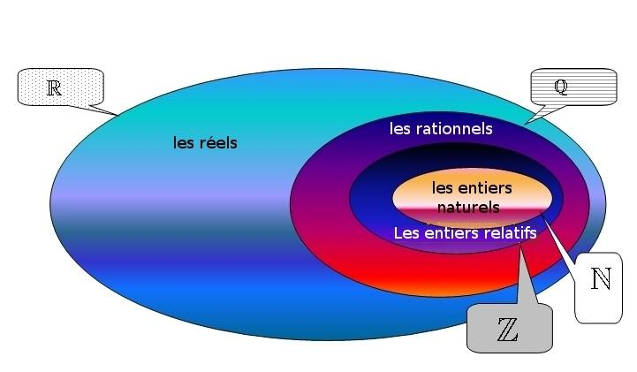


ACTIVITÉS

1.- Réaliser les exercices suivants et simplifier son écriture ainsi que son résultat.

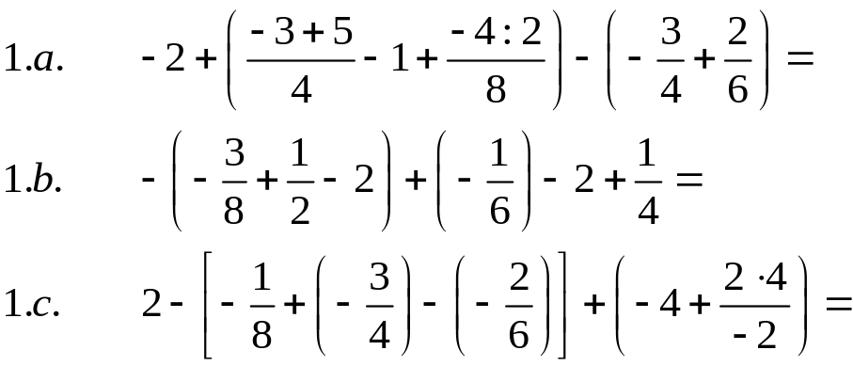

2.- Résous les exercices et simplifie leurs résultats.

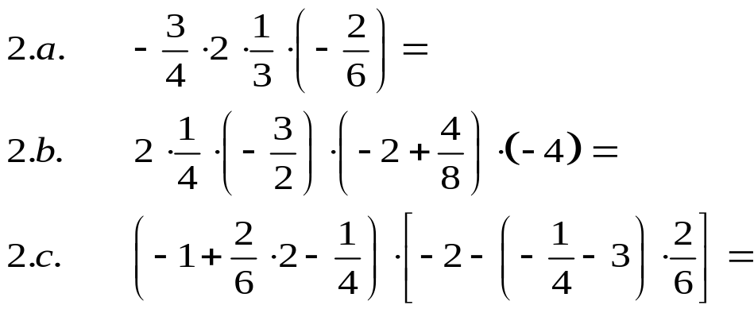

3.- Appliquer la distributivité et résoudre les produits suivants. Après les avoir faits, il faut les faire suivant une autre procédure et vérifier la coïncidence des résultats.

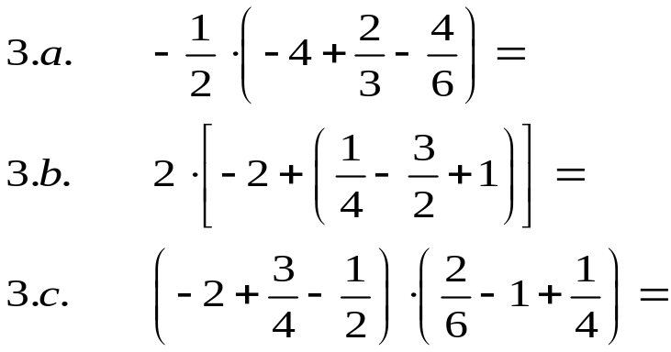

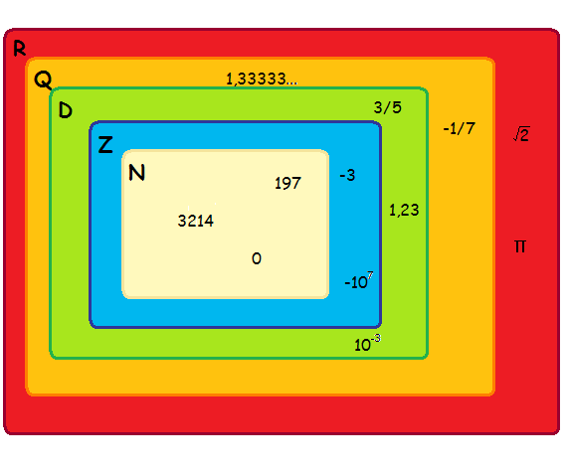

4.- Calculer le résultat de chaque division et simplifie-le.

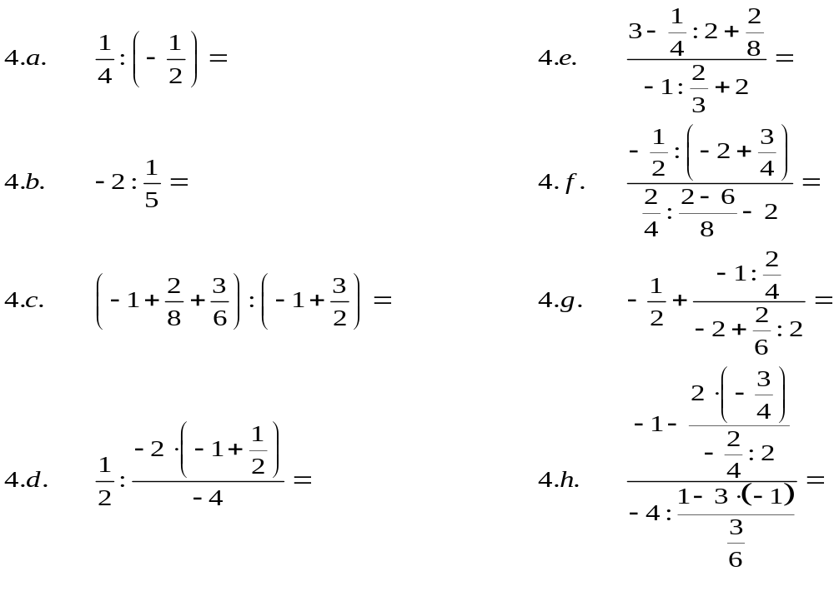
5.- Extraire, dans chaque opération, le facteur indiqué et résoudre l’opération, simplifiant son résultat.

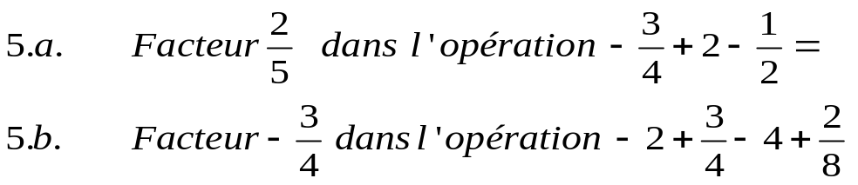

6.- Résous

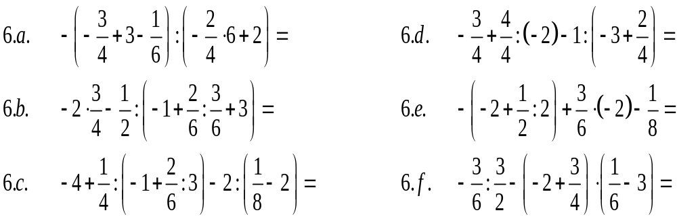

7.- Faire les calculs et simplifier-les.

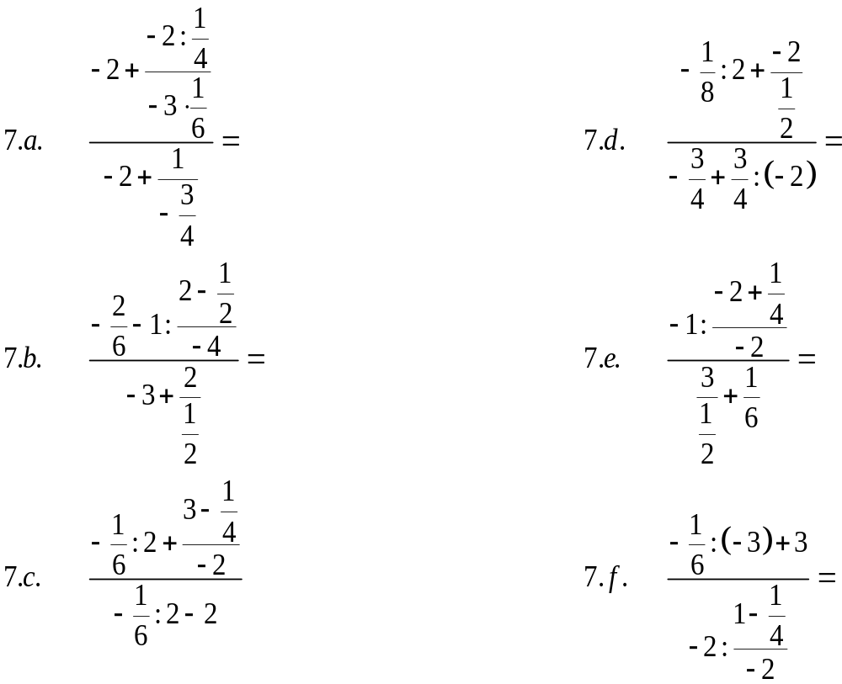

5) Les nombres décimaux:
Un nombre décimal est un nombre qui possède une partie entière
et une partie décimale, séparées par une virgule.

  - Un nombre décimal est le quotient d'un nombre entier par 1, 10, 100, 1000...
  - Dans la pratique, un nombre décimal est un nombre qui peut s'écrire avec une virgule, et dans lequel on peut compter le nombre de chiffres après la virgule.
  - On utilise l'écriture fractionnaire ou l'écriture décimale du nombre en fonction de ce que l'on a à faire.
L'écriture décimale est commode en particulier pour les opérations.

ACTIVITÉS :

1.- Calculer les fractions de lesquelles (fractions génératrices) sortent les nombres décimaux suivants.

2.- Faire les opérations suivantes et donner leurs résultats en forme décimale et, aussi, en forme de fraction.

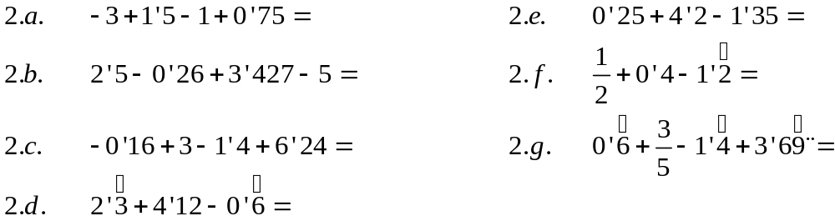

3.- Résoudre et donner les résultats en forme décimale et en forme fractionnaire.

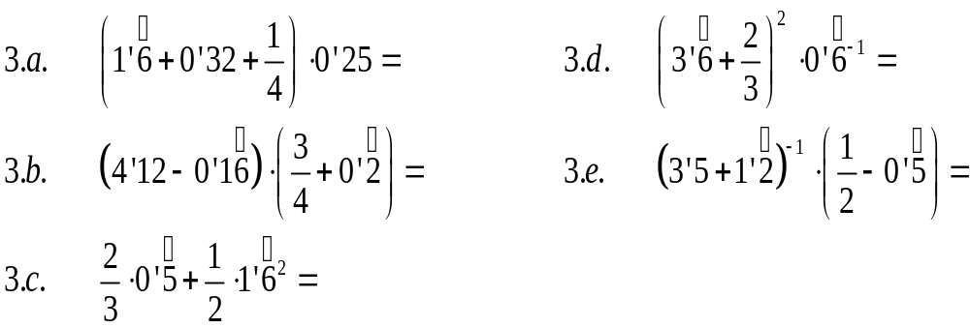
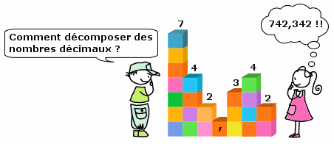

4.- Résoudre et donner les résultats en forme décimale.
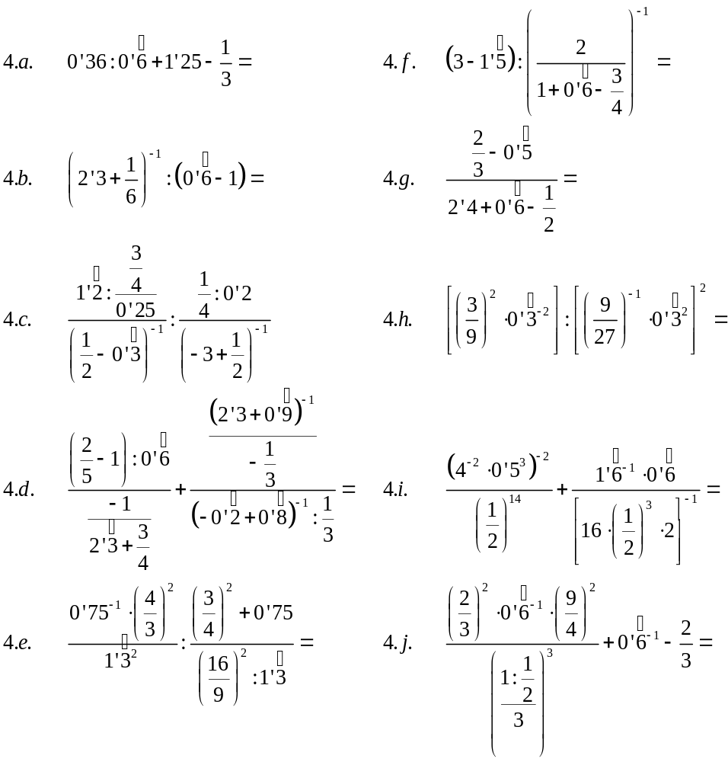

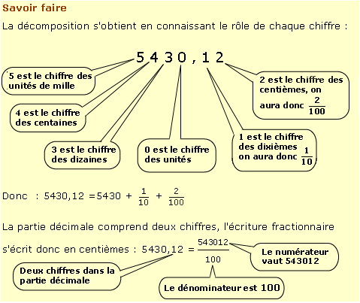

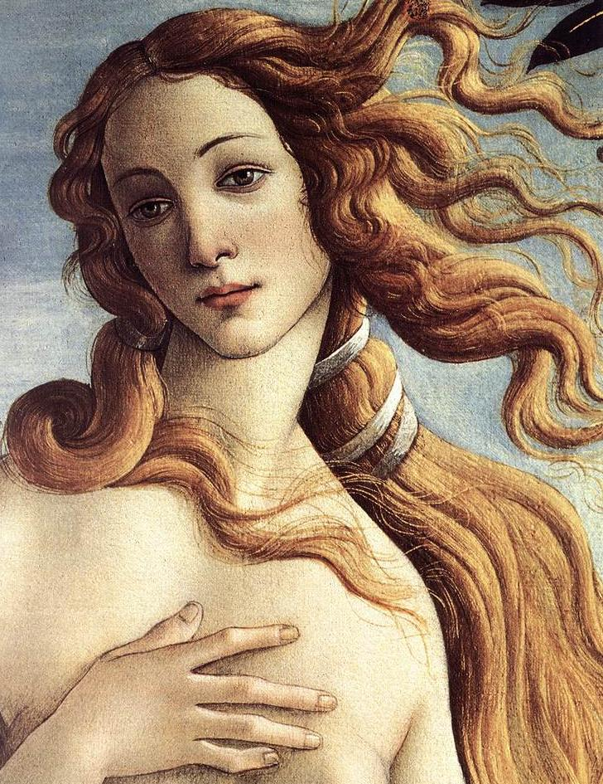

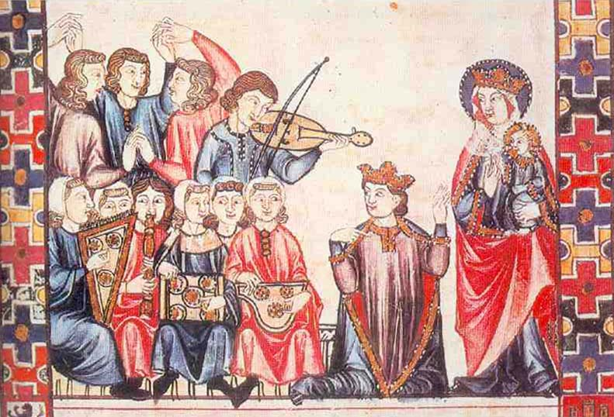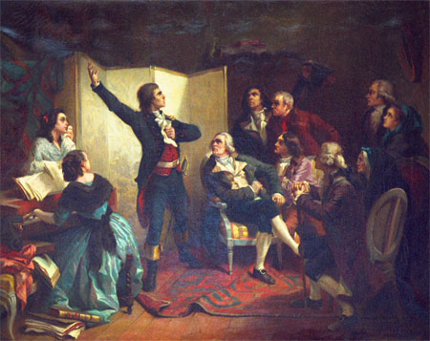

SCIÈNCIES SOCIALES
2º E.S.O.

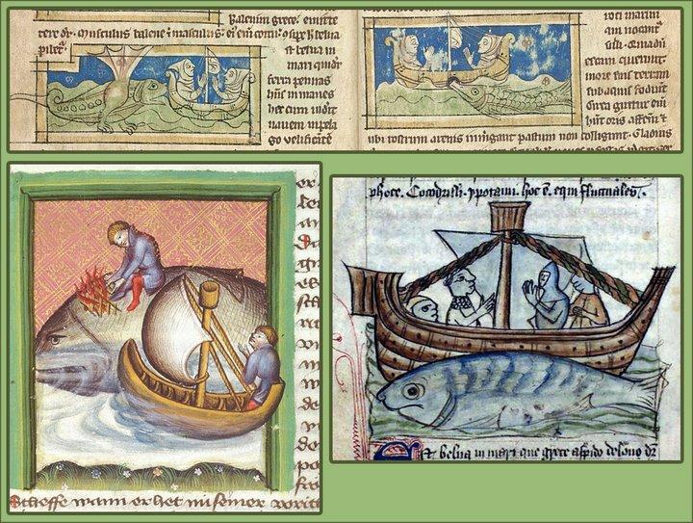

UNITÉ 1 : L ‘ISLAM ET AL-ANDALUS

L’ Islam dans la Péninsule Ibérique: évolution de Al-Andalus. –

Dans son expansion jusqu’à l’Occident, les musulmans, qui dominaient déjà le Nord de l’Afrique, ont commencé la conquête de la Péninsule Ibérique au début de VIIIe siècle. Les armées musulmanes ont traversé le détroit de Gibraltar et ont commencé la conquête du royaume wisigothique. Les wisigoths, affaiblis par leurs disputes internes, ont été incapables de leur faire face. Le roi don Rodrigo est mort dans la bataille de Guadalete et ses troupes se sont dispersées.
Les armées musulmanes ont avancé très vite et ils ont occupé les villes principales de l’Andalousie et Tolède, la capitale du royaume wisigothique. Il leur a fallu 7ans pour contrôler toute la Péninsule, excepté la zone asturienne, où sont refugiés des nobles et des prêtres hispano-wisigothiques.

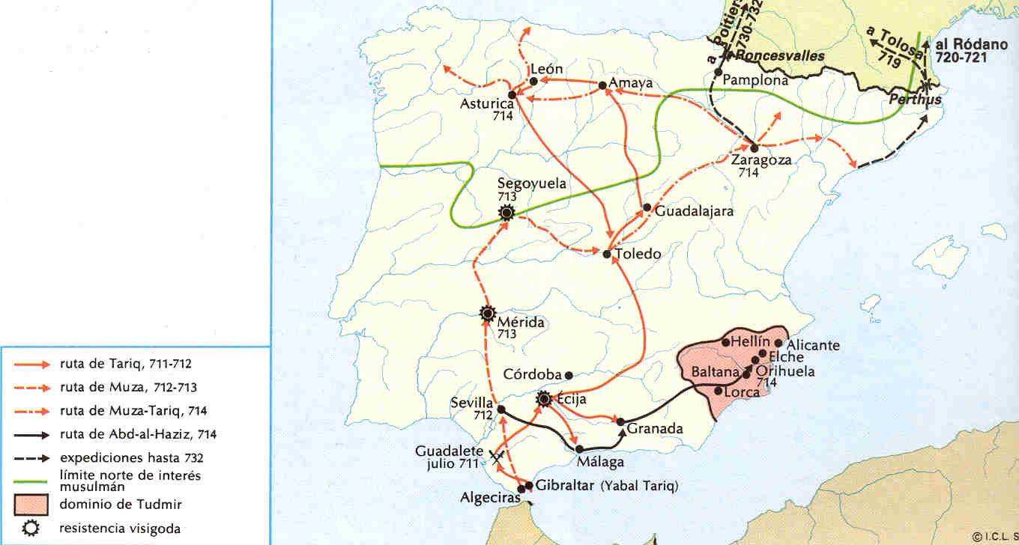

1 – L’Émirat dépendant de Damasco.

Une fois le territoire dominé, alors appelé Al-Andalus par les musulmans, celui-ci est devenu une province ou Émirat dépendant du Califat Omeyyade de Damas (la capitale actuelle de La Syrie). La capitale de l’Émirat s’est établie à Cordoue et un émir a été désigné pour gouverner le territoire.

2– L’Émirat indépendant.

Vers le milieu de VIII siècle, quand les califes omeyydes de Damas ont été vaincus par les Abasies de Bagdad, le dernier membre de la famille Omeyade, Abd-al-Rahman Ier , s’est établi à al-Andalus. Il a rompu très vite avec le Califat de Bagdad et il s’est proclamé un émir indépendant.
Pendant l’Émirat indépendant les disputes internes ont été fréquentes, mais, malgré cela, il s’est produit un important développement économique et culturel.

3– Le Califat de Cordoba.

Au début de Xe siècle, les problèmes dans al-Andalus augmentaient: des disputes internes, des attaques des royaumes chrétiens du Nord (Léon, Castille, Navarre) et des menaces du commerce maritime du côté des musulmans du Nord de l’Afrique. Abd-al-Rahman III a attendu de résoudre ces problèmes, et en 929 il a rompu définitivement avec le califat de Bagdad, et il s’est proclamé calife des croyants d’al-Andalus.
C’est ainsi qu’est né le Califat de Cordoba, et c’est à cette époque que al-Andalus a connu son plus grand développement avec une croissance économique importante et un commerce très actif ; aussi les tentatives de conquêtes des royaumes chrétiens du Nord ont reculé.
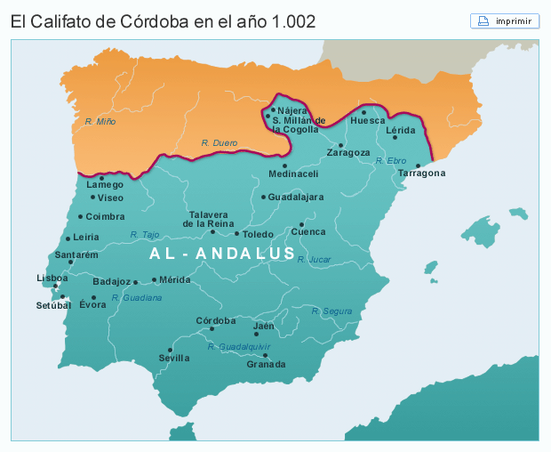

4– Les royaumes de taifas.

Á partir de 1008, l’unité du Califat a commencé à défaire, à cause des luttes internes pour atteindre le pouvoir. En moins de 30 ans, al-Andalus s’est fragmenté en plus de 25 royaumes : les royaumes de taifas, une sorte de villes-état, qui sont entourés de territoire, avec comme centre économique la ville principale. Les taifas les plus importants ont été Séville, Tolède, Badajoz, Saragosse, Murcie y Grenade.
Les taifas ont vécu une époque de grande prospérité économique, mais ils ont été incapables de freiner l’avancée des armées chrétiennes. Malgré l’arrivée de nouveaux peuples originaires du Nord de l’Afrique (almoravides y almohades), les royaumes chrétiens ont conquis toutes les terres de al-Andalus.
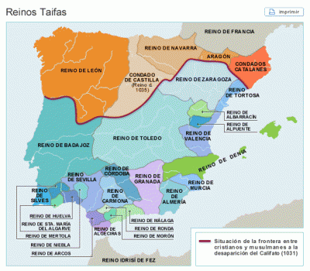

5– Le royaume taifa de Granada.

L’unique royaume qui est survécu à l’avancée des royaumes chrétiens au XIII siècle est celui de Grenade. Il était gouverné par des sultans de la dynastie nazari. Ce royaume comprenait un vaste territoire qui embrassait les provinces actuelles de Malaga, Almería, Grenade et une partie de Cadiz. Son énorme richesse et sa grande activité économique lui permettaient de payer beaucoup d’impôts aux rois de Castille, ce qui a rendu possible son existence jusqu’à le fin du XVe siècle.

ACTIVITÉS.
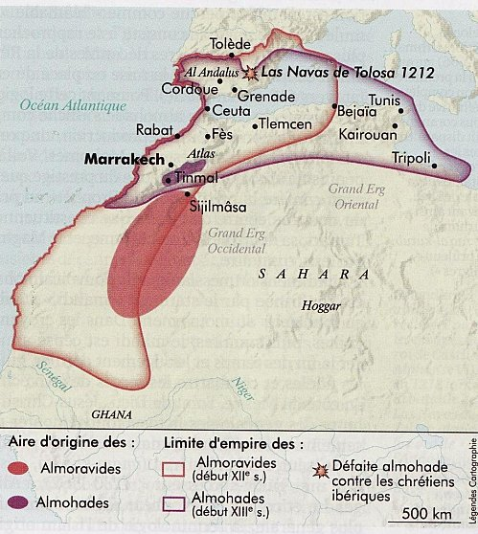
- Quand et où débarquent les armées musulmanes sur la Péninsule Ibérique?

…………………………………………………………………………………………………………………………………………………………………………………………….………………………………………………………………………………………………………………………………………………………………………………………

- Pour envahir la Péninsule, quelles routes suivent-ils ? Quelles villes conquissent- ils ?
.....................................................................................................................................................................................................................................
…………………………………………………………………………..………
.........................................................................................................................................................................................................................................................................................................................................................................................................................................................................................................

- Quels territoires restent relativement à l’écart de cette invasion?

.....................................................................................................................................................................................................................................................................................................................................................................................................................................................................................................................

- Á quel endroit de la Gaulle les musulmans sont vaincus et obligés de se retirer?

................................................................................................................................................................................................................................................................................................................................................................................................................................................................................................

- Pourquoi la conquête musulmane de la Péninsule Ibérique est si rapide?

....................................................................................................................................................................................................................................................................................................................................................................................................................................................................................................................................................................................................................................................

- Explique les causes qui provoquent l’indépendance de l’Émirat dépendant.

......................................................................................................................................................................................................................................................................................................................................................................................................................................................................................................................................................................................................................................................................................................................................................................................................................................................................................................................

- Qu’est ce que c’est le Califat de Cordoue? ..............................................................................................................................................................................................................................................................................................................................................................................................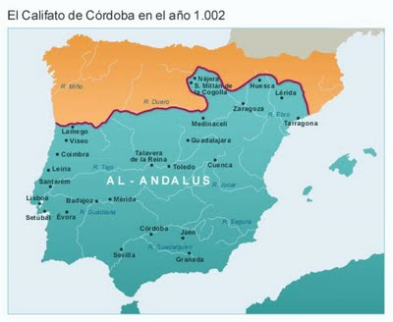

Qui le fonde? Quand disparaissent-ils?

…………………………………………………………………………………………………………………………………………………………………………………………………………………………………………………………………………………………………………………………………………………………………………………………………………………………………………………………………………………………………………………………………………………………………………………………………………………………………………………………………………………………………………………………………………………………………………

- Explique ce que sont les royaumes de taifas. Quelles armées musulmanes viennent les aider? Quand sont-ils définitivement vaincus ?

…………………………………………………………………………………………………………………………………………………………………………………………………………………………………………………………………………………………………………………………………………………………………………………………………………………………………………………………………………………

- Qu’est ce que c’est que le royaume taifa de Granada? Quelles causes rendent possibles sa survie jusqu’au XV siècle?
...........................................................................................................................................................................................................................................................................................................................................................................................................................................................................................................................................................................................................................................................

- Indique les principaux royaumes de taifas au XI siècle.
...........................................................................................................................................................................................................................................................................................................................................................................................................................................................................................................................................................................................................................................................

- Vocabulaire :

Al-Andalus: nom que les mjusulmans donnaient aux territoires de la P´ninsule Ibérique qui étaient sous son pouvoir.

Émirat: province de l’Empire Islamique, qui était gouverné par un émir.

Califat: nom de l’Empire Islamique, gouverné par un califa, chef religieux et politique dont le pouvoir était absolu. Il était juge suprême, général des armées et il pouvait désigner et destituer tous les postes publiques.

Royaumes de taifas: des royaumes qui sont sortis de la décomposition du Califat de Cordoba.

Almorávides et almohades: des peuples originaires du Nord de l’Afrique qui sont Venus à aider aux musulmans d’Al-Andalus en leur lutte contre les royaumes chrétiens du Nord de la Péninsule Ibérique.
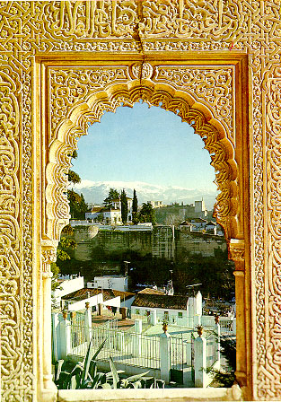
Dynastie nazari: famille royale qui a régné dans le royaume taifa de Granada jusqu’à sa disparation au XV siècle.

UNITÉ 2 : L’EUROPE FÉODALE. 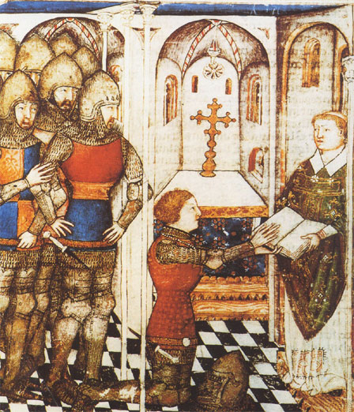

Les origines du féodalisme. –

Aux XI et XII siècles l’Europe Occidentale était en crise. Una série de peoples attaquaient et envahissaient l’Europe: au Nord les normandes, au Sud les musulmans, à l’Est les hongrois, ce qui causait beaucoup de morts et destructions.

Le pouvoir des rois était très faible dans cette situation. Ils ne pouvaient pas protéger la population, ni récolter les impôts, ni entretenir une armée fidèle. Les monarques ont du compter sur les nobles pour pouvoir gouverner et entretenir son royaume uni, établissant avec eux un système de relations personnelles connu comme la vassalité.

La vassalité s’établissait grâce á la cérémonie du hommage: le vassal, á genoux devant le roi, il lui jurait fidélité et il lui promettait: conseil, aide militaire et économique. Le roi lui donnait en échange le fief (investiture) parce qu’il le gouvernait et il vivait de lui. C’est l’origine du féodalisme.

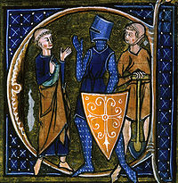
Le pouvoir était sous la main de ces seigneurs féodaux, qui se sont transformés en la seule autorité des territoires différents du royaume et ils se sont faits presque indépendants. Les paysans venaient á eux en quête de protection.

La société féodale. –

La société était profondément inégale. Elle était partagée en 3 ordres, qui étaient des groupes sociaux auxquels on appartenait dès la naissance et pour toute la vie.

D’un côté, il y avait les groupes privilégiés:
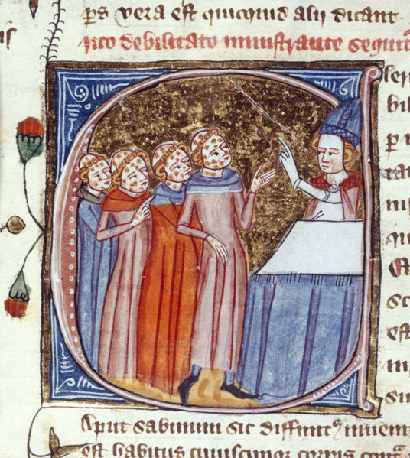
- La noblesse s’occupait de la défense militaire et de la guerre.

- Le clergé, des moines et des curés, s’occupait de la prière et de l’Eglise.

Ils formaient une petite partie de la population, mais ils jouissaient de tous les privilèges: ils avaient le plupart des terres, le pouvoir militaire, économique et religieux.

- D’un autre côté, il y avait le groupe non privilégié. Dans ce groupe nous pouvons différencier les paysans, qui formaient la plus grande majorité de la population, et les artisans, qui constituaient un secteur très petit.

Sa fonction était de travailler et d’entretenir les autres deux ordres. Ils étaient soumis á eux et ils n’avaient pas de droits.

ACTIVITÉS.

1. – À l’aide du texte et du document, réponds aux questions.

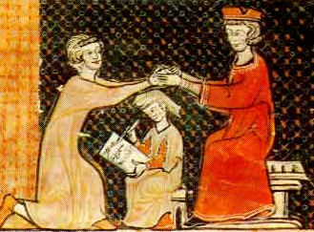

(1) “Le comte a demandé au futur vassal s’il voulait devenir son “homme”. Celui-ci a répondu “je le veux”. Puis, les mains jointes dans celles du comte, ils se sont alliés par un baiser. (2) En deuxième lieu, celui qui avait fait hommage dit “Je jure d’être fidèle au comte Guillaume”. (3) Ensuite le comte lui a donné l’investiture de son fief”.
D’après Galbert de Bruges, 1127.

- Sur la miniature, indique qui est le comte et qui es le vassal
.................................................................................................................................................................................................................................................................................................................................................................................................................................................................................

- Quel moment de l’hommage est représenté ici, 1, 2 ou 3?
.................................................................................................................................................................................................................................................................................................................................................................................................................................................................................

- Que fait le personnage du milieu? Pourquoi est-il figuré plus petit que les autres?
.................................................................................................................................................................................................................................................................................................................................................................................................................................................................................

2. – Quel est l’origine du féodalisme?
..........................................................................................................................................................................................................................................................................................................................................................................................................................................................................................................

3. – Quelle est la vassalité?
.................................................................................................................................................................................................................................................................................................................................................................................................................................................................................

4. – Quels sont les trois ordres que nous distinguons dans la société féodale?
...........................................................................................................................................................................................................................................................................................................................................................................................................................................................................................................
Quelle fonction a chacun d’eux?
............................................................................................................................................................................................................................................................................................................................................................................................................................................................................................................

5.- Qui sont les privilégiés? Et les non privilégiés?
..........................................................................................................................................................................................................................................................................................................................................................................................................................................................................................................

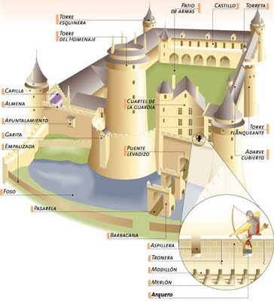

VOCABULAIRE.

Féodalisme: système politique, économique, sociale et culturelle qui s’établi dans l’Europe Occidentale à partir du IX-X siècles.

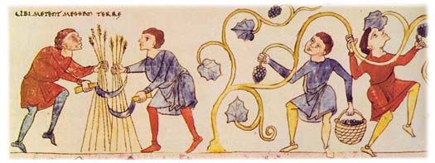

Fief: lot de terres que le Roy donnait au seigneur féodale parce qu’il le gouvernait et il vivait de lui.

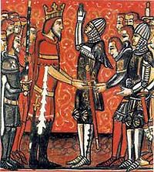Vassalité: système de relations personnelles entre les rois et les grands seigneurs, nobles et clercs, pour pouvoir gouverner et entretenir unis leurs royaumes.

Hommage: cérémonie pour laquelle on établissait la vassalité.

Ordres: groupes sociales renfermés de l’époque féodale. On appartenait à eux dès la naissance et pour toute la vie.

Privilèges: droits exclusifs que la noblesse et le clergé avaient dans l’époque féodale. Les plus importants étaient le pouvoir militaire, économique et religieux, et la possession des terres.

Noblesse: ordre privilégie de la société féodale qui s’occupait de la défense militaire et de la guerre.

Clergé: ordre privilégié de la société féodale, composé des moines et des cures, qui s’occupaient de la prière et de l’Église.

UNITÉ 3 : LA VILLE MÉDIEVALE. 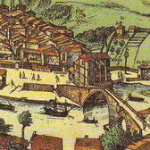

La societé urbaine.

La croissance des villes a transformé la société féodale avec l’apparition d’un nouveau groupe social non privilégié, la bourgeoisie, composée de personnes dédiées au travail artisanal et au commerce, qui ne dépendaient d’aucun seigneur féodal.
La base de leur richesse était l’argent qu’ils encaissaient pour leur travail, pour la vente de leurs produits ou pour les bénéfices de leurs commerces. Selon leur richesse, on distinguait la grande bourgeoisie, composé de commerçants et banquiers riches, et la petite bourgeoisie, composé de maîtres artisans et des petits commerçants.
En plus de bourgeois, il y avait aussi des grands seigneurs nobles et ecclésiastiques, qui habitaient dans les villes. Attirés par la richesse et l’activité urbaines, ils fixaient leur résidence (des palais, des couvents, des églises) dans la ville.

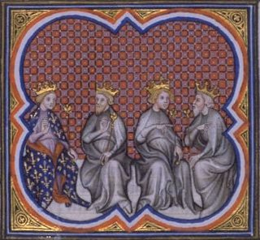

Des autres groupes sociaux habitaient aussi dans les villes: des officiers et des apprentis des corporations, des domestiques, des personnes sans métier et des mendiants, ainsi que des minorités comme les juifs, qui habitaient dans des quartiers séparés, les quartiers juifs.

Le gouvernement des villes.

À l’origine, les villes ont formé des communautés ou assemblées de tous les habitants pour organiser leur gouvernement. Ultérieurement, on a élu des magistrats, qui veillaient aux finances, l’ordre y la justice, guidés par un maire. La mairie était le bâtiment où ils se réunissaient.
Avec le temps, le gouvernement des villes est tombé entre les mains des familles les plus riches de commerçants et bourgeois, qui ont constitué un groupe privilégié de la ville.
La culture urbaine.

Au X et XI siècles, dans l’Europe Occidentale, lire et écrire était une tâche réservée aux prêtres, fonctionnaires royaux et quelques marchands riches. Cependant, au fur et à mesure que le XII siècle a avancé, l’amélioration des conditions économiques et le développement de la vie urbaine ont favorisé une plus grande instruction entre quelques nobles et surtout entre les bourgeois qui se consacraient au commerce.
Ce besoin de connaissances a favorisé le développement des écoles dans les villes, qui dépendaient de l’Église ou du gouvernement de la ville. Bientôt, le désir des professeurs et étudiants de pouvoir apprendre sans le contrôle des autorités religieuses ou municipales, a donné lieu à la formation des corporations appelées universités.

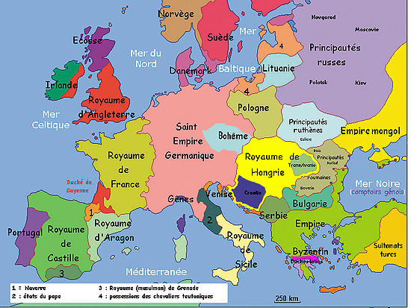

ACTIVITÉS.

- Quel nouveau groupe social s’est développé dans les villes?
..................................................................................................................................................................................................................................................................................................................................................................................................................................................................................................
- Quelle est la différence entre la grande et la petite bourgeoisie?
...................................................................................................................................................................................................................................................................................................................................................................................................................................................................................................

- Pourquoi les grands seigneurs nobles et ecclésiastiques se sont établis dans les villes?
..................................................................................................................................................................................................................................................................................................................................................................................................................................................................................................

- Comment on organisait le gouvernement des villes?
…………………………………………………………………………………………………………………………………………………………………………………………………………………………………………………………………………………….....................................................................................................................................

- Quels changements culturels se sont produits avec le développement urbain?
………………………………………………………………………………………………………………………………………………………………………………………………………………………………………………………………………………….........................................................................................................................................

- Pourquoi ont apparu les universités? 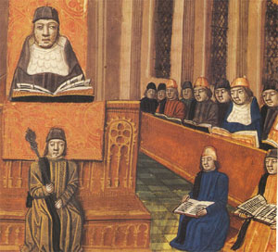
…………………………………………………………………………………………………………………………………………………………………………………………………………………………………………………………………………………….....................................................................................................................................

VOCABULAIRE.

- 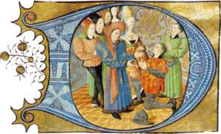Bourgeoisie: groupe social composé de personnes consacrées au travail artisanal ou au commerce.

- Mairie: bâtiment où le maire se réunissait avec les magistrats pour le gouvernement de la ville.

- Université: corporation créé à partir du XII siècle par des professeurs et étudiants qui ne voulaient pas apprendre sous le contrôle des autorités religieuses ou municipales.

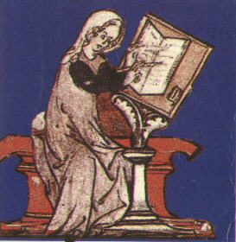

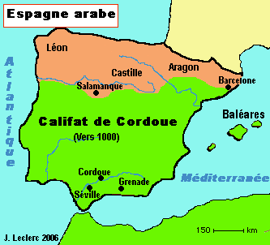UNITÉ 4 :
LA FORMATION ET L’EXPANTION DES ROYAUMES PÉNINSULAIRES

L’origine des royaumes occidentaux. –

Au VIII siècle, la plupart de la Péninsule Ibérique avait été occupée par les musulmans, qui ont établi un État puissant: Al-Andalus.
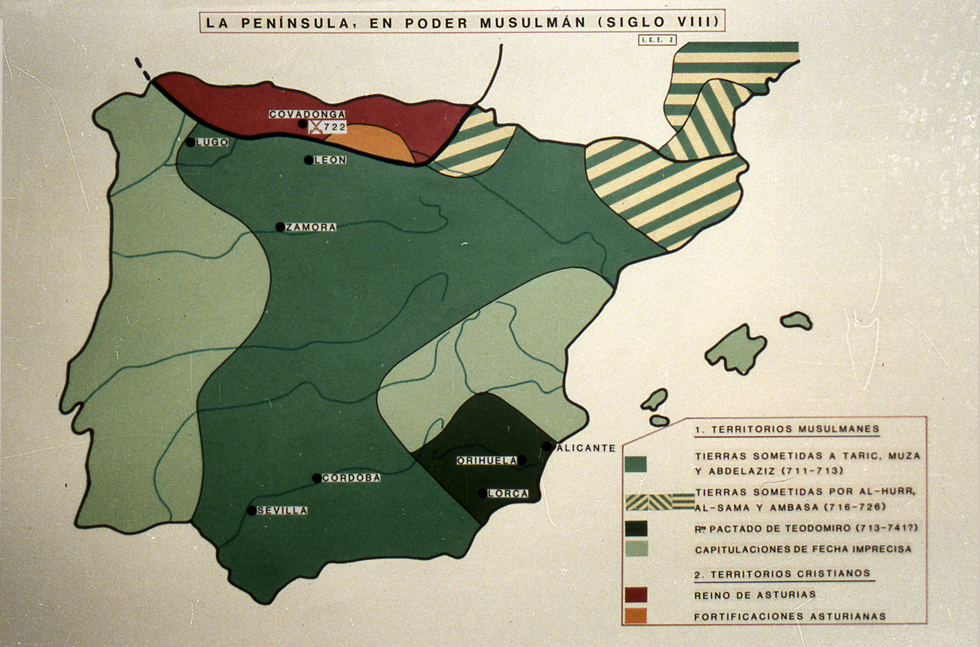

Cependant cette domination dans la Péninsule n’a pas été totale. Dans la zone montagneuse du Nord, habitée par des cantabres et des astures, quelques nobles wisigothiques se sont refugiés et ils ont créé le premier centre de résistance à Al-Andalus; le royaume d’Asturies.
Selon la tradition, l’origine du royaume d’Asturies provient de la victoire du noble wisigothique Pelayo sur les musulmans pendant la bataille de Covadonga, qui a été considérée comme le début de la Reconquête, c’est-à-dire, la conquête par les royaumes chrétiens des terres qui avaient été occupés par les musulmans.

Les successeurs de Pelayo ont étendu le nouveau royaume jusqu’en Galice et jusqu’au fleuve Douro. Vers le milieu du IX siècle on a déplacé la capitale à Leon pour mieux surveiller les nouvelles terres occupées. C’est pour ça que le royaume d’Asturies est devenu le royaume de Leon.

Alfonso III a fortifié le territoire de l’Est de la Meseta avec de nombreux châteaux. C’est pourquoi cette zone a reçu le nom de comté de Castille et elle a été gouvernée par des comtes nommés par le roi de Leon. L’un de ces comtes, Fernan Gonzalez, est devenu indépendant du royaume leones.
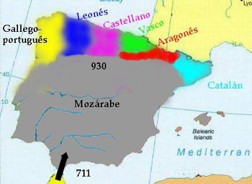

L’origine des royaumes orientaux. –

Dans la zone des Pyrénées, les premiers centres chrétiens de résistance ont jailli de l’alliance entre la noblesse wisigothique et les rois francs. Charlemagne, roi des francs, a organisé la Marca Hispánica,
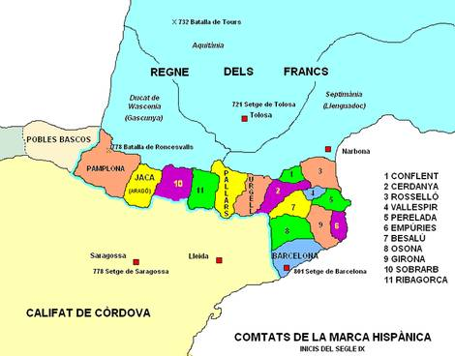

qui était la province frontalière entre le fleuve Èbre et les Pyrénées. Cette Marca était divisée en comtés gouvernés par des comtes qui dépendaient du roi franc et elle a été créé pour protéger la frontière sud de l’empire des attaques musulmanes.
Au début du IX siècle, une famille noble de Pamplona, les Arista, a expulsée les gouverneurs francs et a créé le royaume de Navarre.
Dans la même époque, les hispano wisigothiques de Jaca ont rompu leurs liens de dépendance avec les francs et ils ont créé les comtés aragonais.
Les comtés catalans ont continué sous la depéndanse des francs jusqu’au X siècle, quand le comte de Barcelona, Borrell II, a refusé de leurs jurer fidélité.

ACTIVITÉS.

- – Où se trouvait la frontière entre le royaume de Leon y Al-Andalus au début du X siècle?.....................................................................................................................................................................................................................................................................................................................................................................................................................................................................

- – Où se trouvait le comté de Castille? D’où vient son nom?
.......................................................................................................................................................................................................................................................................................................................................................................................................................................................................

- – Quels sont les premiers royaumes chrétiens qui se sont formés dans la Péninsule? Quels territoires comprenaient-ils?
...............................................................................................................................................................................................................................................................................................................................................................................................................................................................................................

- - 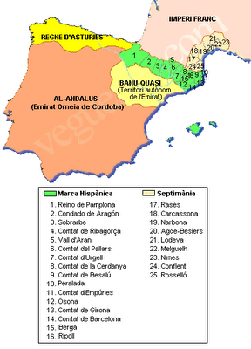
Qu’est ce qu’était la Marca Hispánica?..............................................................................................................................................................................................................................................................................................................................................................................................................................................................................................................................................................................................................................................................................................................................................................................

- – 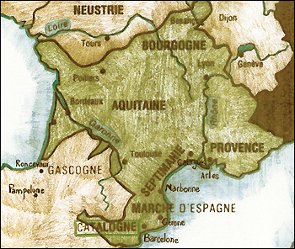 Quels centres chrétiens se sont créés dans les Pyrénées pendant le IX siècle?
.....................................................................................................................................................................................................................................................................................................................................................................................................................................................................

- – Quand les habitants de Pamplona sont devenus independants des francs? Et ceux d’Aragon?
.........................................................................................................................................................................................................................................................................................................................................................................................................................................................................................................

- – Comment les comtés catalans sont devenus independants?
......................................................................................................................................................................................................................................................................................................................................................................................................................................................

VOCABULAIRE.

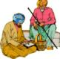Reconquête: la conquête par les rois chrétiens des terres qui avaient été occupées avant par les musulmans.

Marca Hispanica: province de l’empire de Charlemagne, creée pour protéger la frontière sud des attaques musulmanes. Elle était situé entre le fleuve Èbre et les Pyrénées

TEXTE : L’invasion arabe
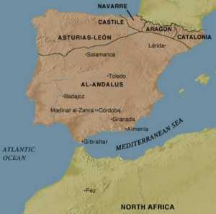 Au siècle VIII (vers l’an 711), les arabes, aussi appelé musulmans ou maures, venant du nord de l’Afrique, ont envahis la péninsule ibérique par le Sud, après avoir traversé le détroit de Gibraltar. Commandés par Tarique, ils ont battus les visigoths lors de la bataille de Guadalete. Ils ont réussis à prendre possession de tout la péninsule à l’exeption des montagnes de Asturias, au Nord, où se réfugièrent de nombreux chrétiens.
L’influence des arabes est fortement restée au Portugal puisqu’ils sont restés plus de 5 siècles (711-1249) dans une grande partie du territoire actuel du Portugal et de l’Espagne. Les vestiges de ce peuple sont accentués surtout au Sud du pays dans la région du Algarve. La connaissance scientifique était très importante dans les domaines des mathématiques, de l’astrologie, architecture, sculture, poésie, musique, médecine et navigation. Ils ont principalement érigés des temples (mosquées) et palais encore présent comme vestiges au Portugal. La culture musulmane s’est enraciné dans la culture portugaise dans l’horticulture, la langue portugaise et aussi le nom de villes tels que Algarve, Aljezur ou Alcantara.
Les maures ont été définitivement expulsés du Portugal en 1249 avec la prise de la ville Faro, au Algarve, par le roi D. Afonso III.


EQUIPO BILINGÜE ESPAÑOL-FRANCÉS
3º TOMO
CURSO 2010-2011

